Step 1: open the photo
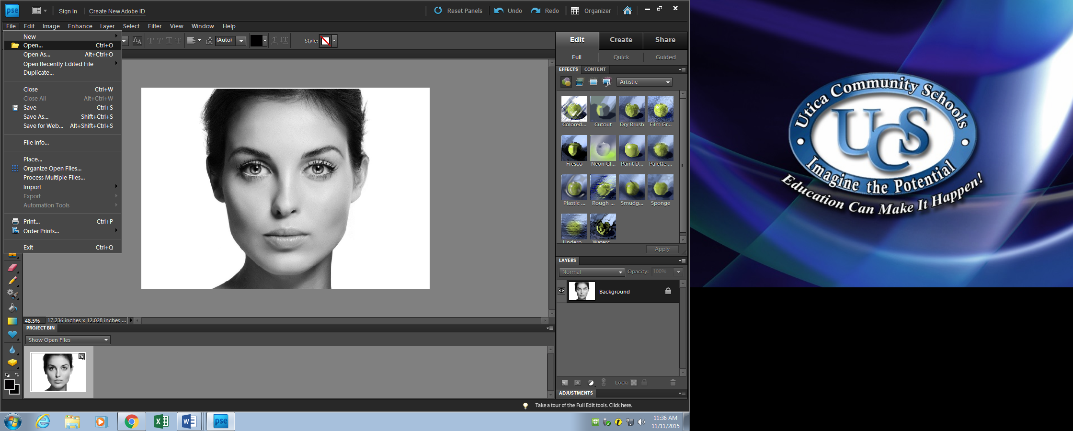
Step 2: Create New Layer
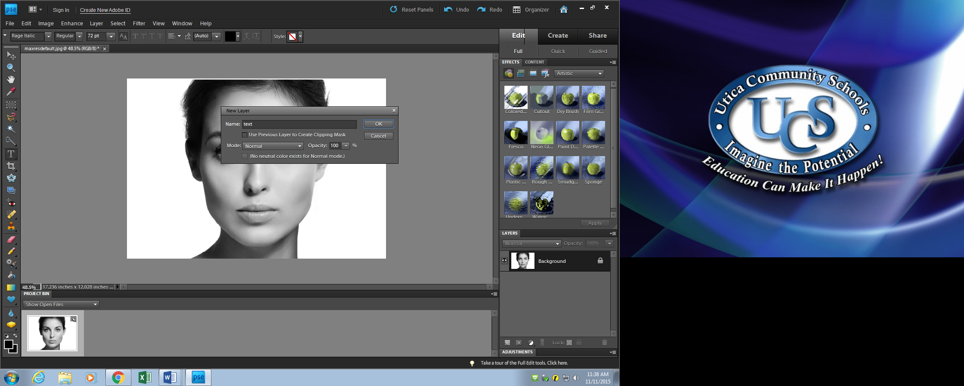
Step 3: name layer “text”
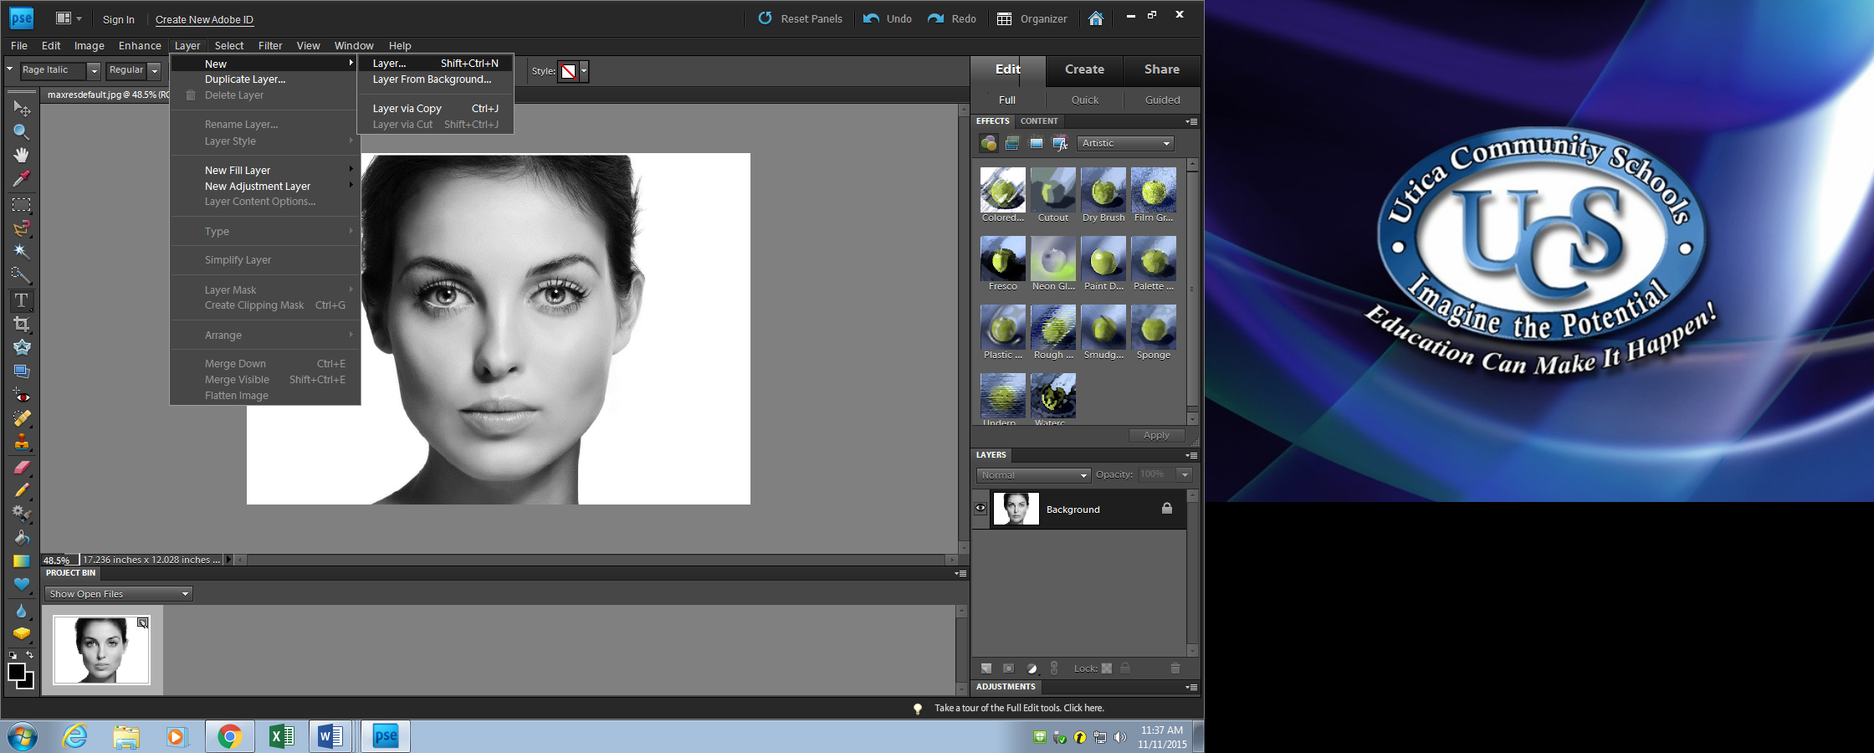
Step 4: Select Horizontal Text tool make sure you are working in the “text” layer
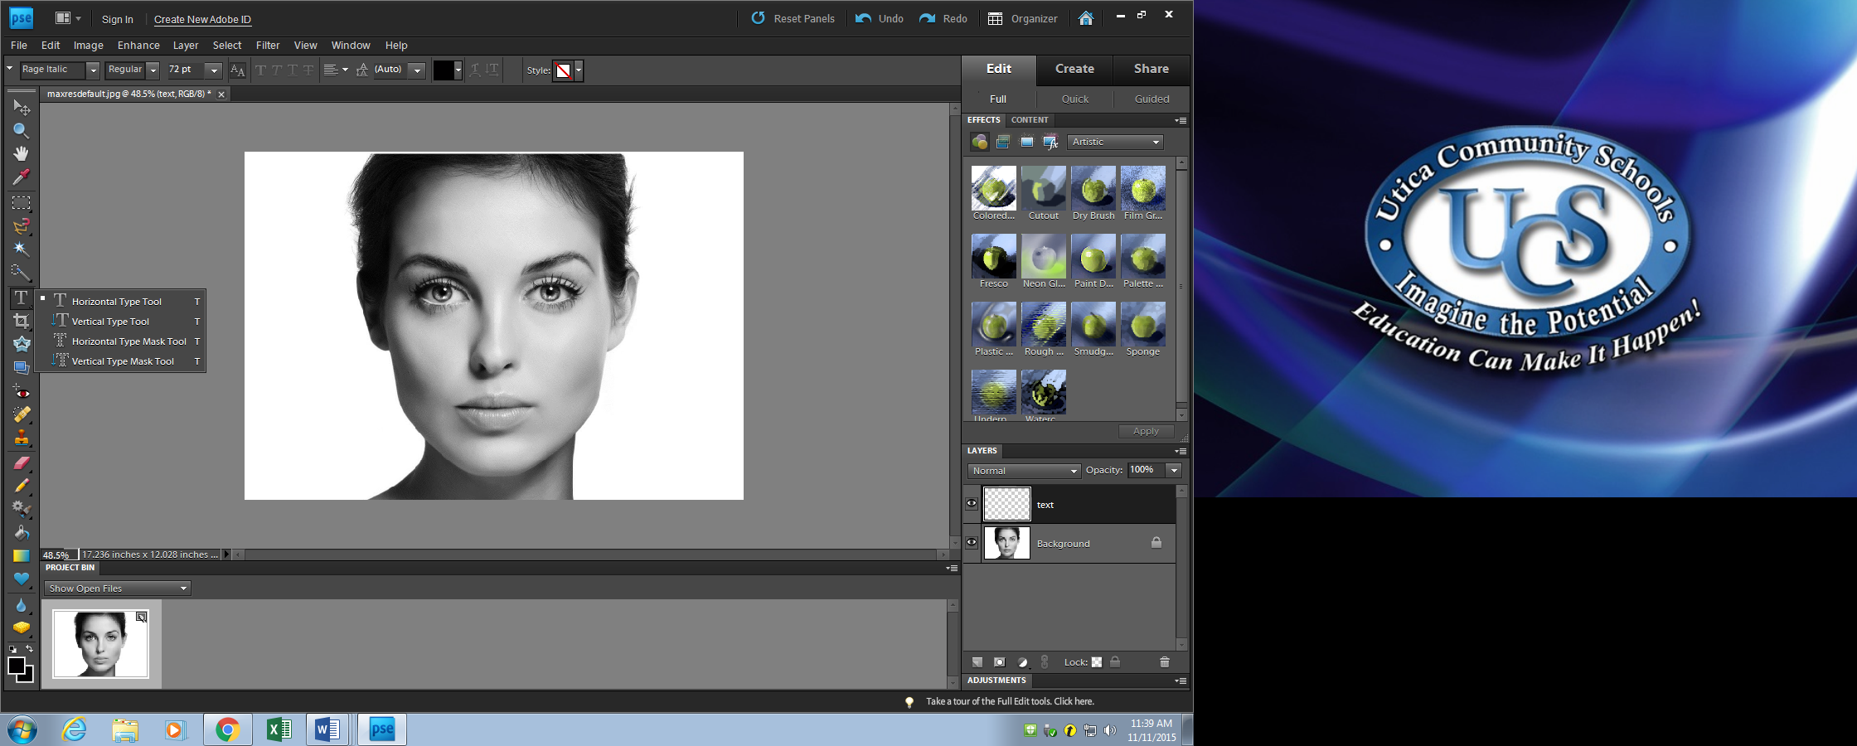
Step 5: Create a text selection by clicking and dragging a text box around the portrait
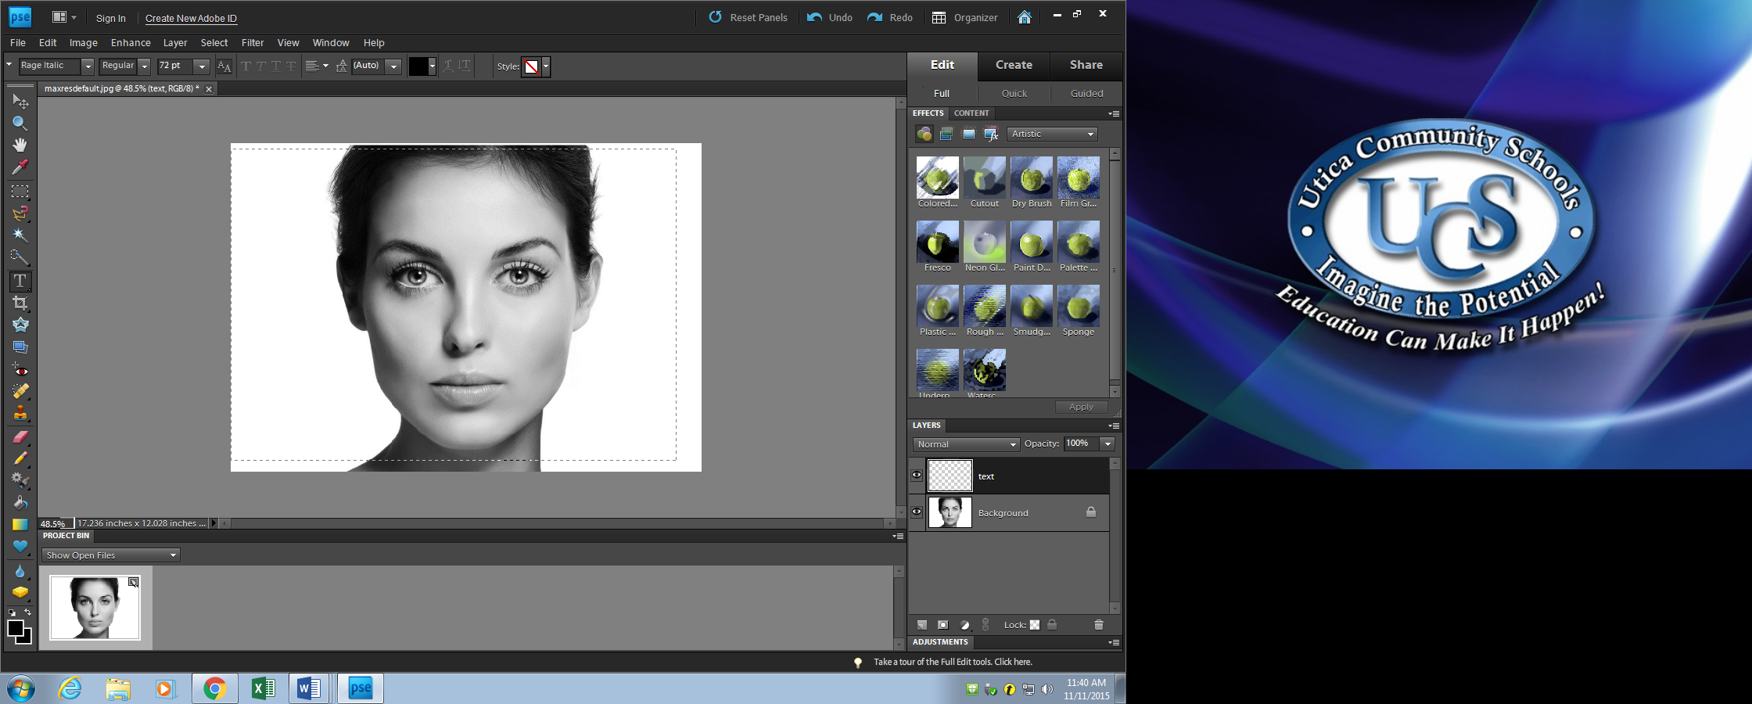
Step 6: Add text. You can copy text from a word document and paste into your text box OR you can type directly into your “text” Make sure you have set the size and font to what you want
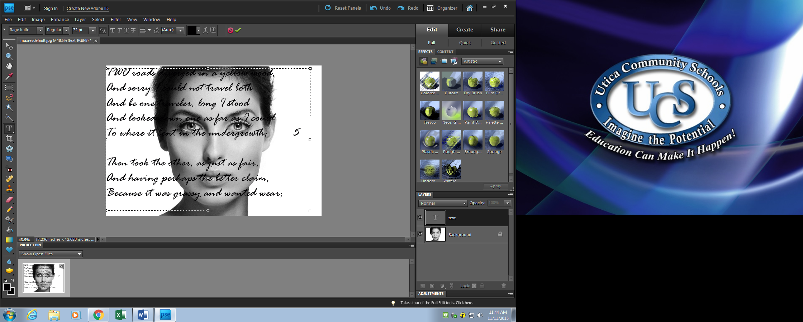
Step 7: Make a copy of the text layer by dragging the “text” layer to the new layer icon (corner flippy uppy square)
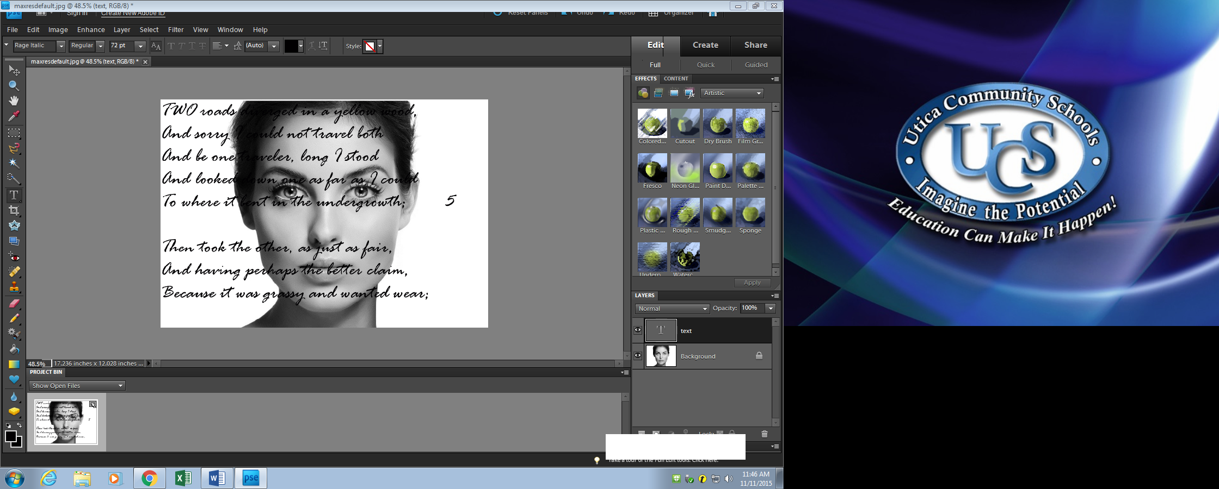

Step 8: select the “move” tool in the upper left hand tool selection window, click on the text and move it so it the duplicate text separates from the original text. Move this text anywhere you want on the portrait.
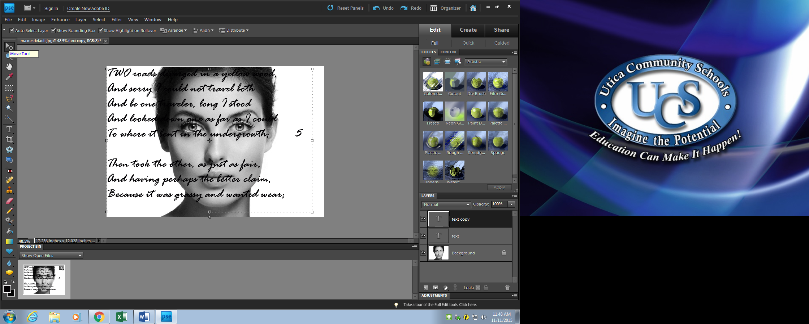
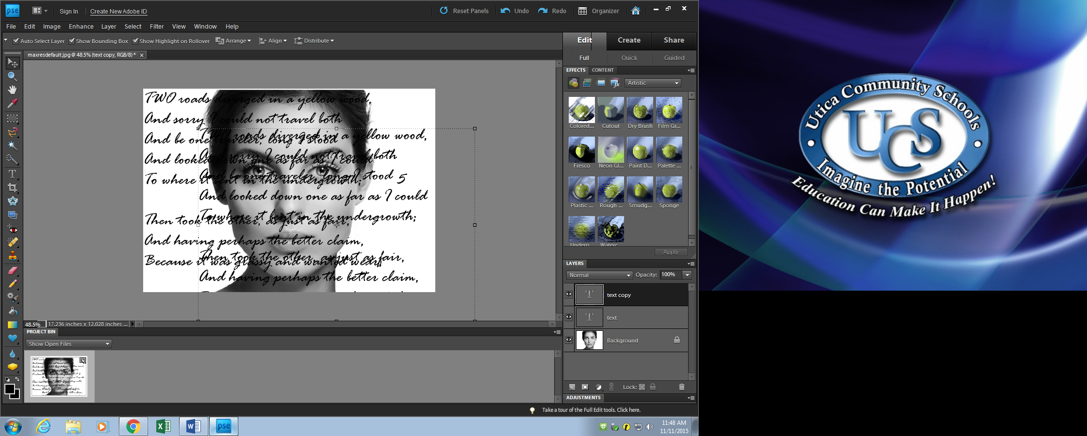
Step 9 repeat this process until you are satisfied 3-5 layers
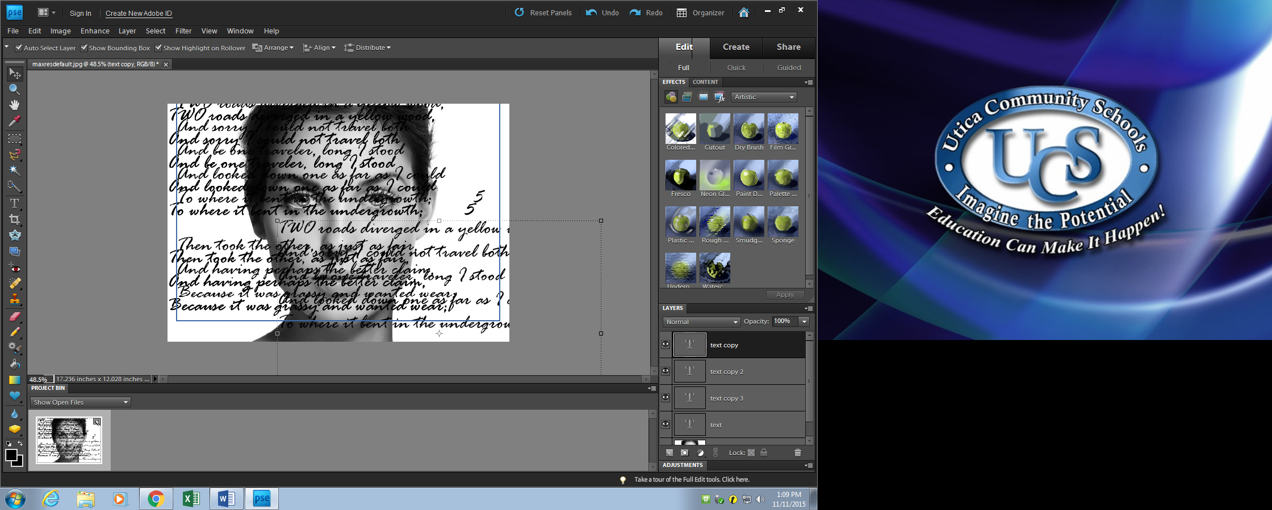
Step 10: In each text layer change color, size, effect, and orientation by double clicking on the T in each text layer ( you will know you did this when the text on your portrait is highlighted) until you are satisfied. You may even choose to delete all but one or 2 words in your layer and make uber large.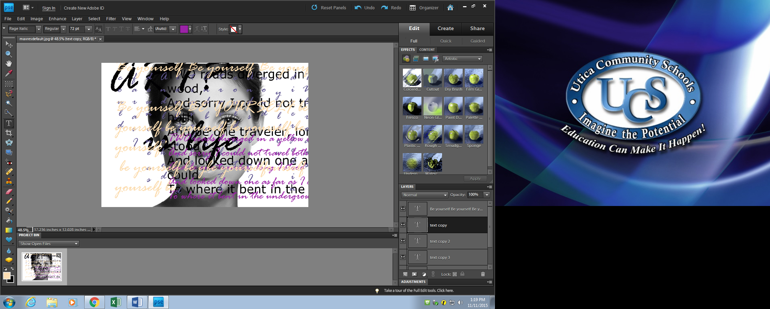ake REALLY large.

Step 11: click on the top “text layer, hold shift (keep holding down shift) and scroll down to the last “text layer and click on it. Your will see all text layers have been highlighted and selected. Let up on shift key
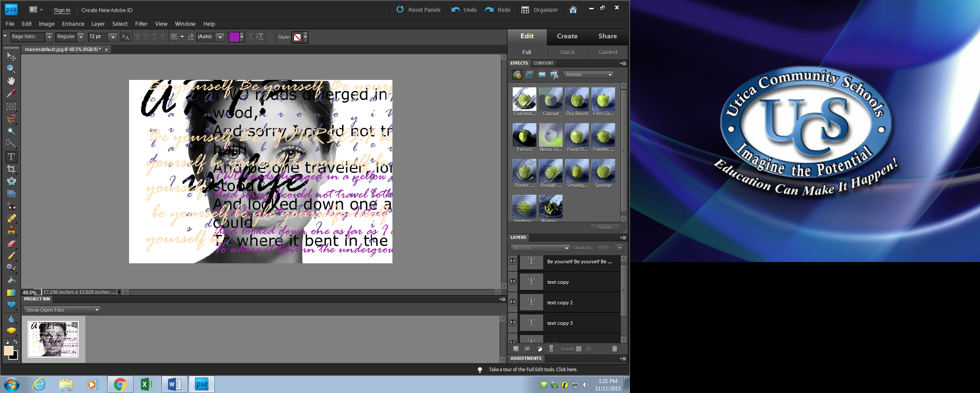

Step 12: Go to “layer” and select “merge layers” all text layers will smoosh into 1
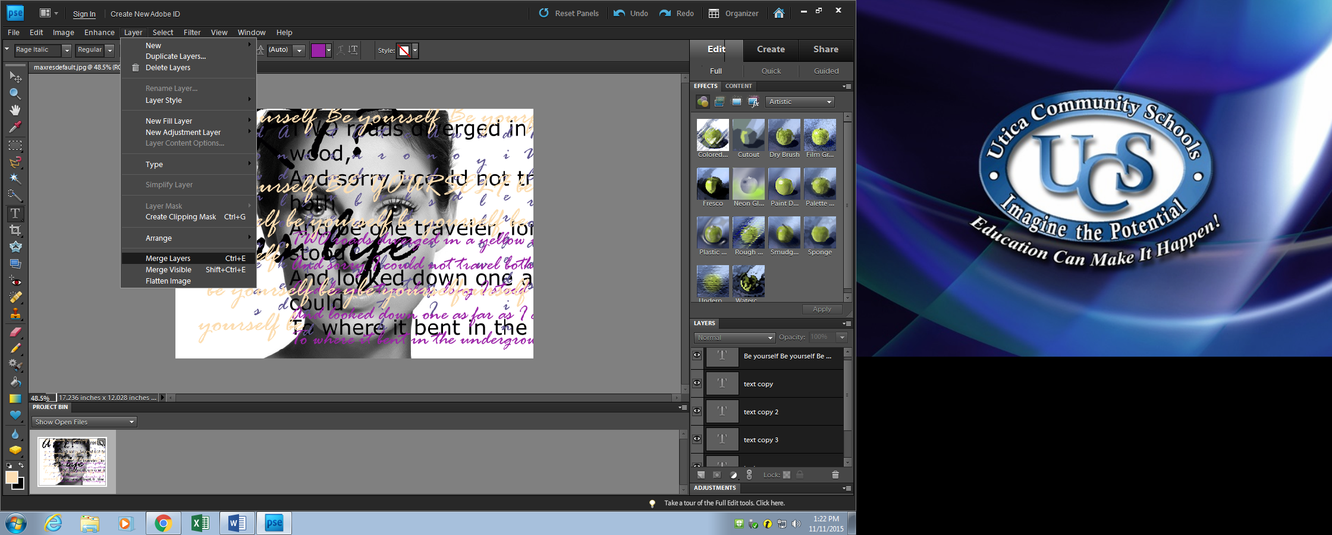Step 13: click on the word “normal” next to the opacity section in the “layers” window. A drop down menu will appear. Select “overlay” (make sure you are working in the “text” layer
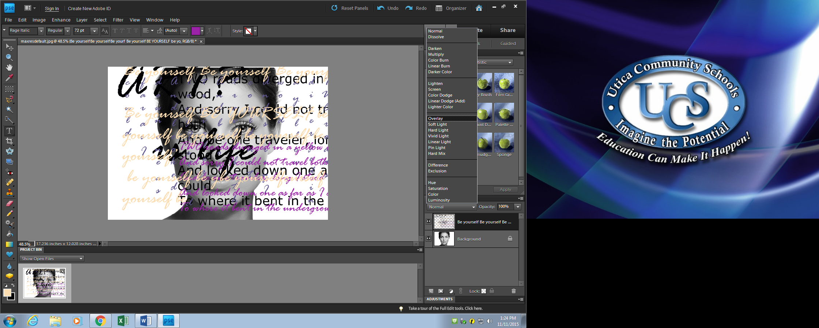
Step 14: Go into the “filter” menu. Go down to “distort” and select zig zag. Make sure you are working in the “text layer”
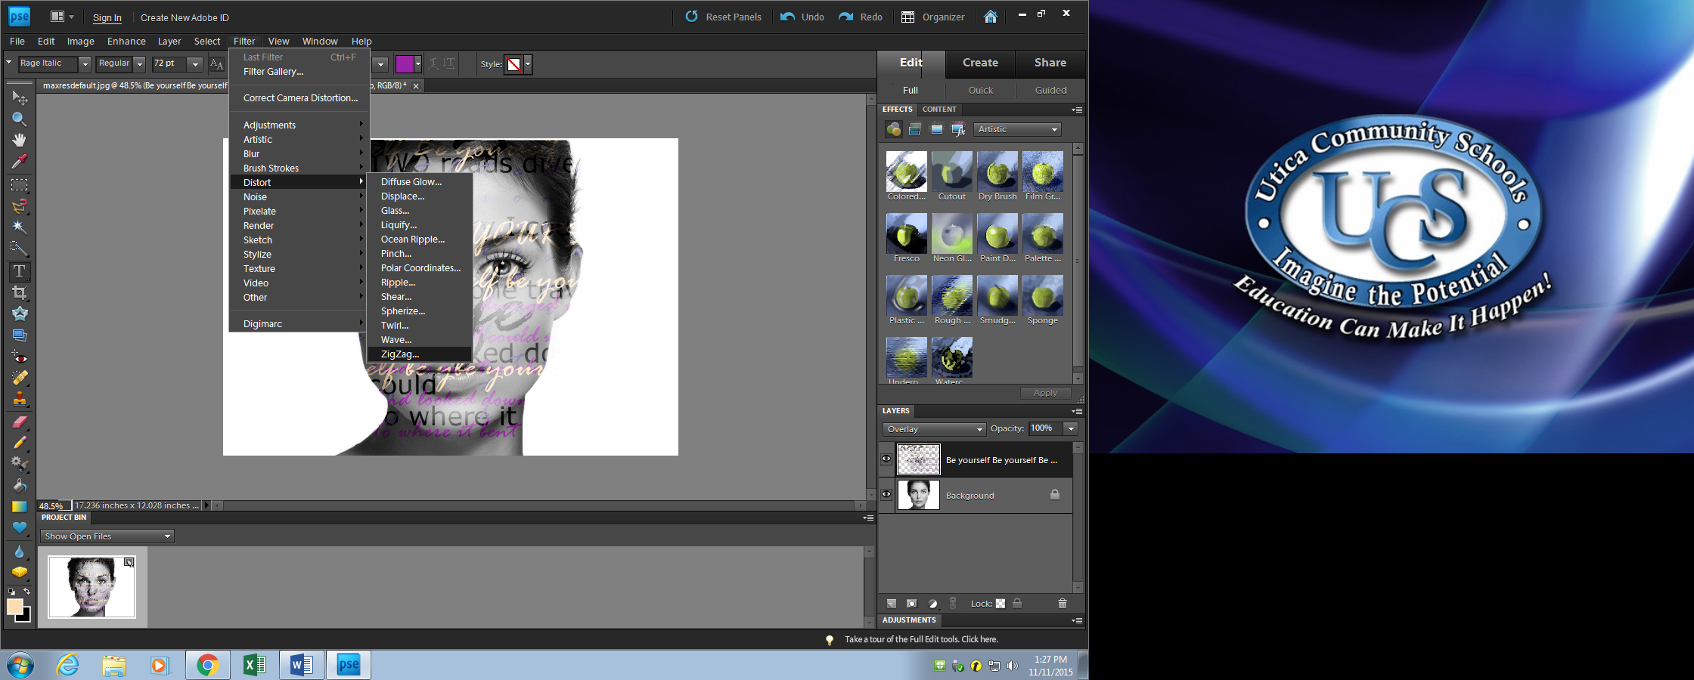

Step 14: Adjust the “amount” and ridges.
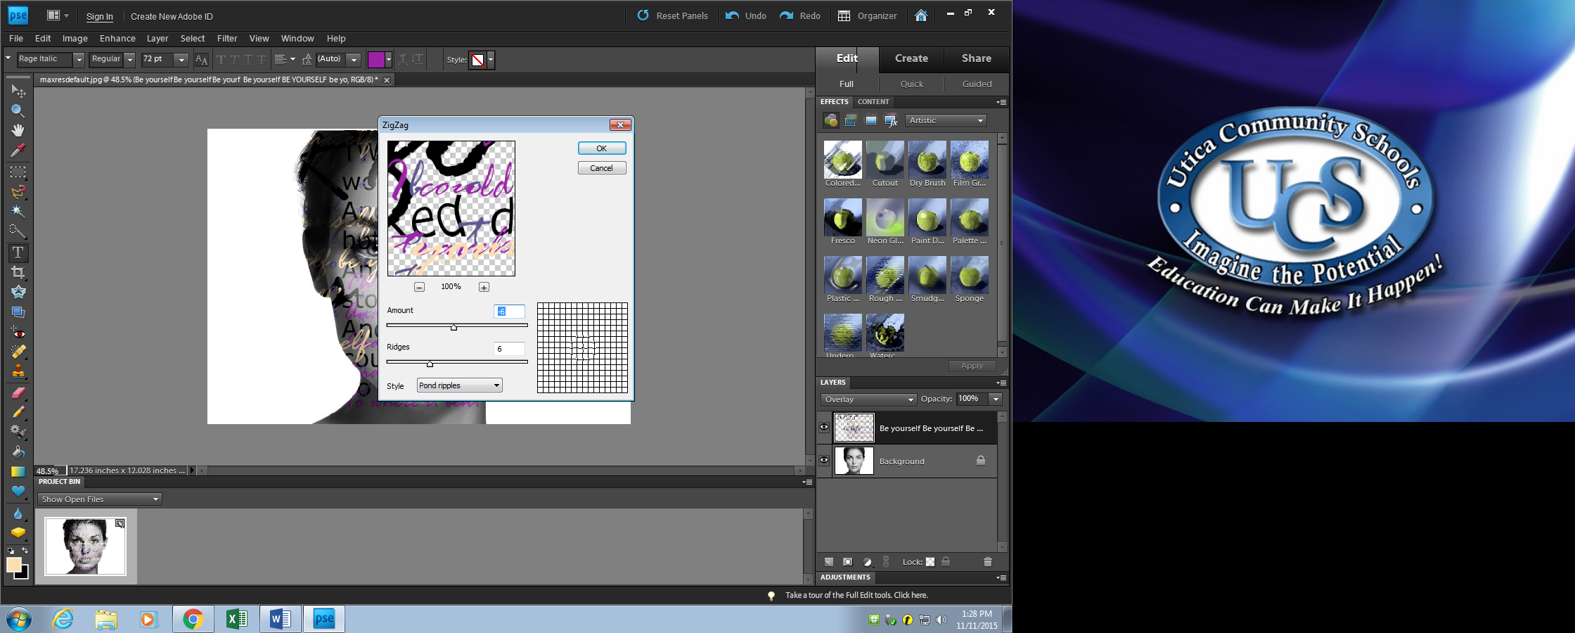
Step 15: If you are unsatisfied with the appearance hit “undo” and try agai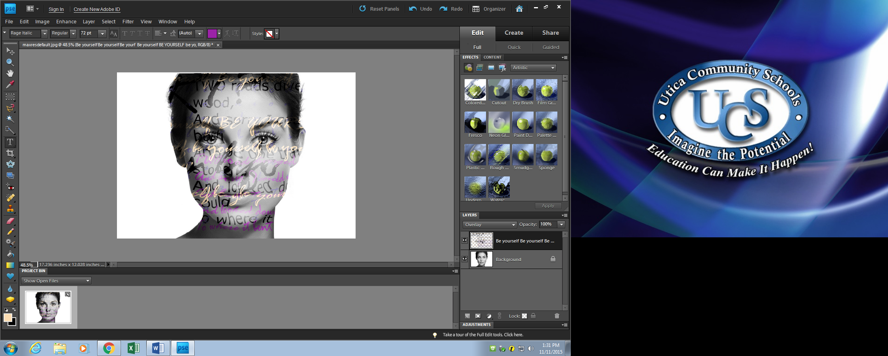n
Step 16: When you are satisfied with you text portrait go to the “layers” drop down menu and select “flatten image”
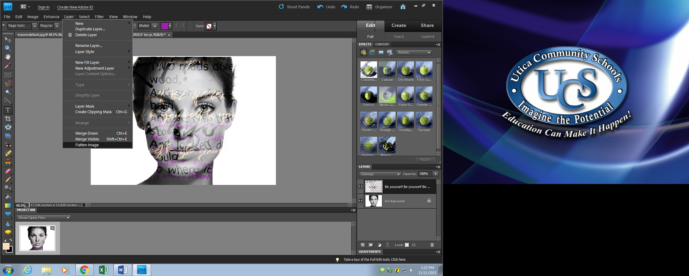
Step 17: Go to “file” select “save as” desktop
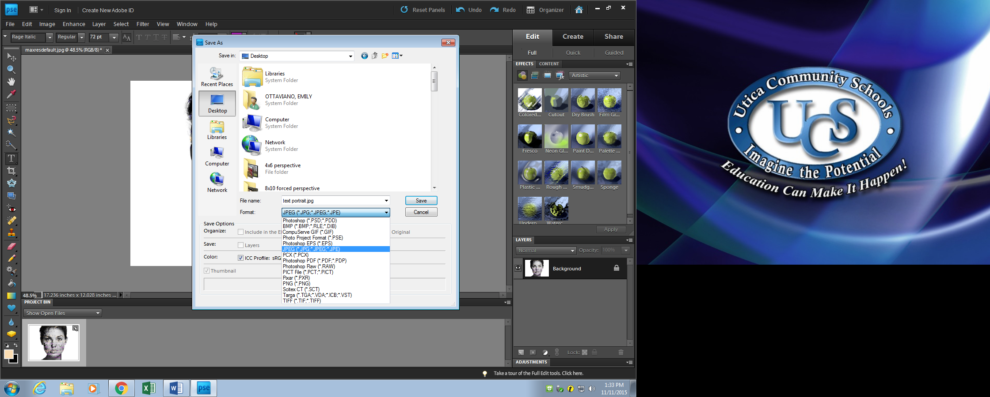
Step 18: set quality to “8”
