- Create a new blank file by File - New
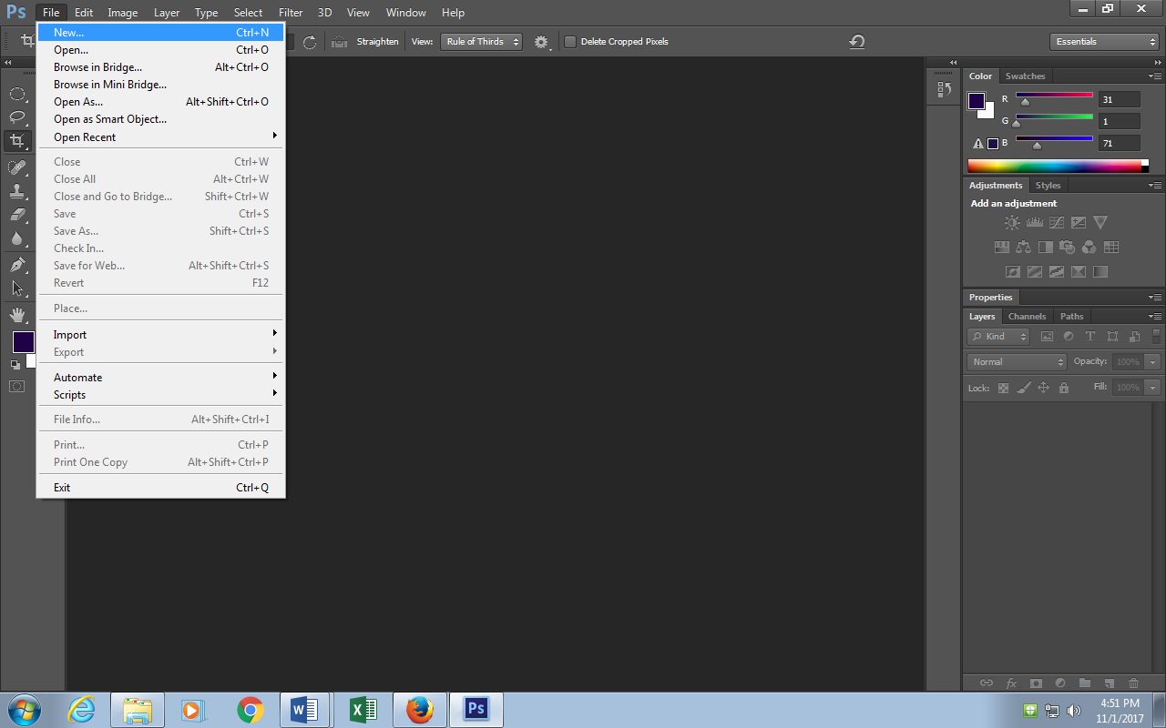

- Title the image “cutout” Set the preset to “Photo” and Size “Landscape 8x10”
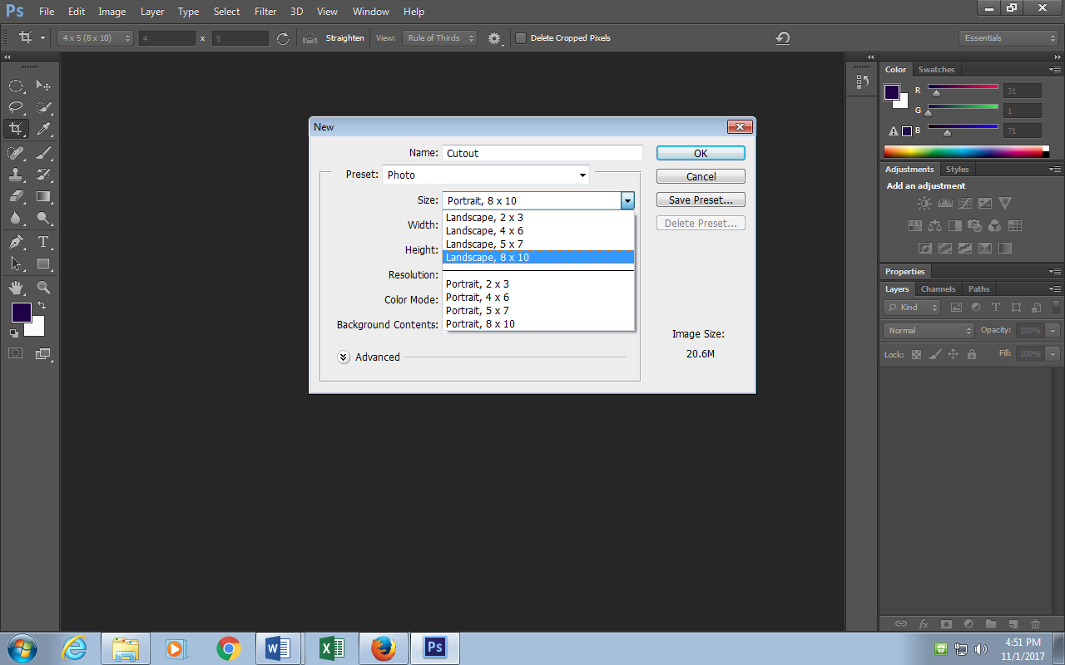

- Create a New Layer: Layer – New – Layer
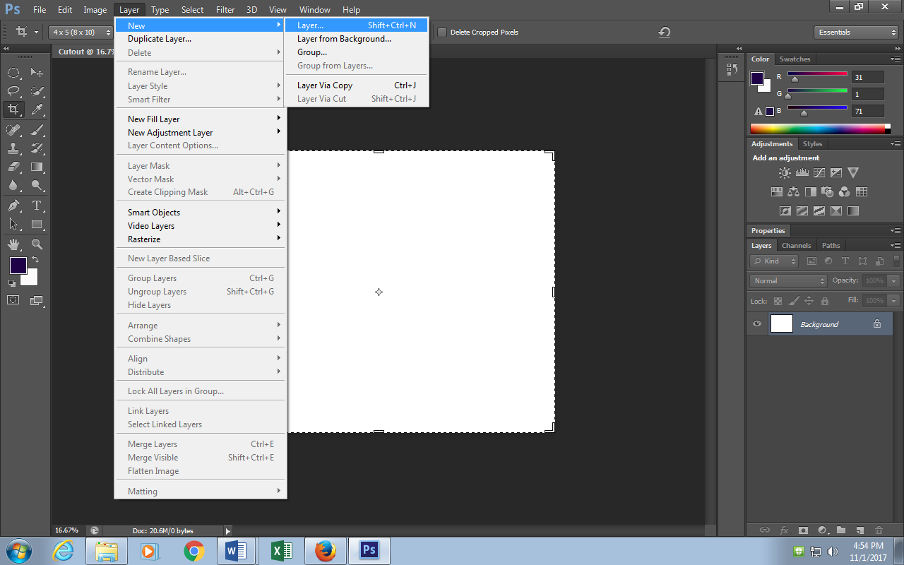
- Title layer “Beach”
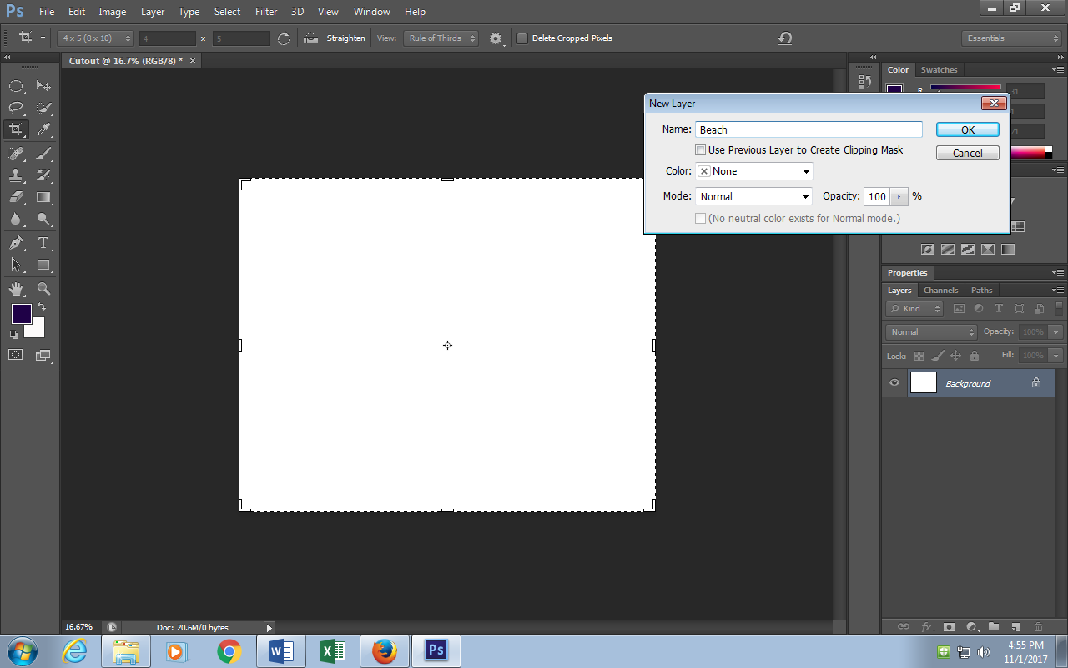

- Go to file – Place
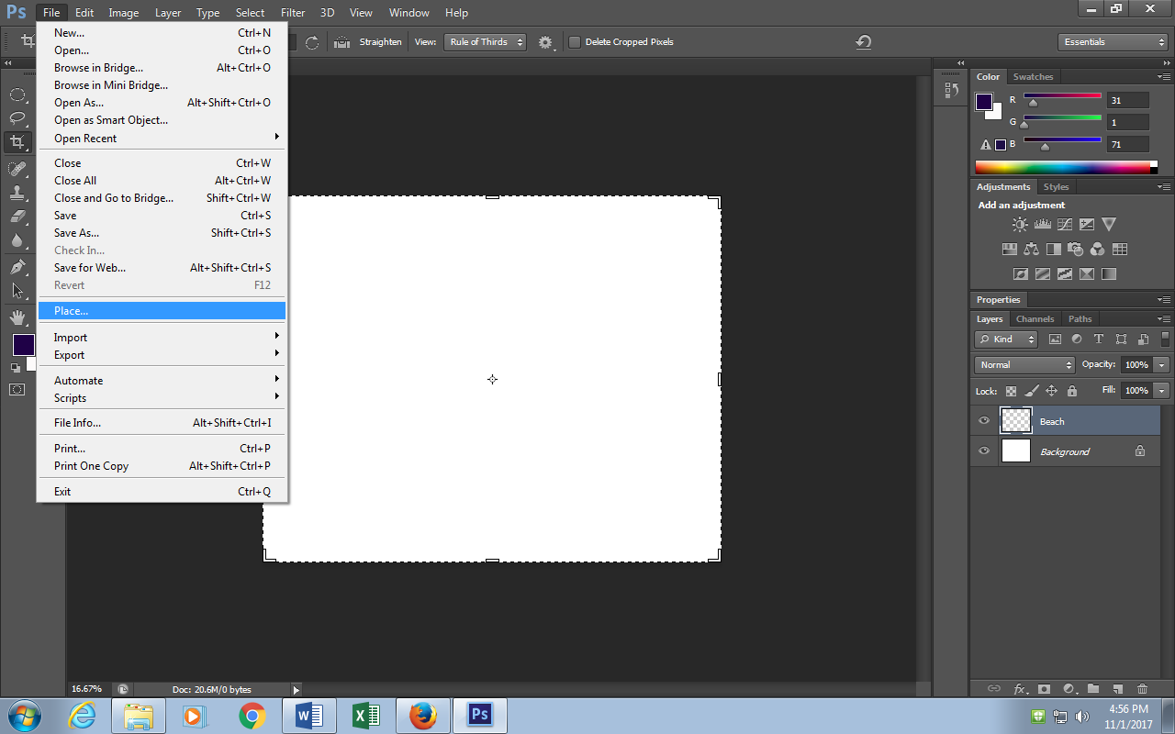
- Go to STUCOMMON and select the Beautiful Beach image to place in the new layer.
- Hold shift down while pulling on the corners of the image to fill the whole layer (No White) Hit enter when done

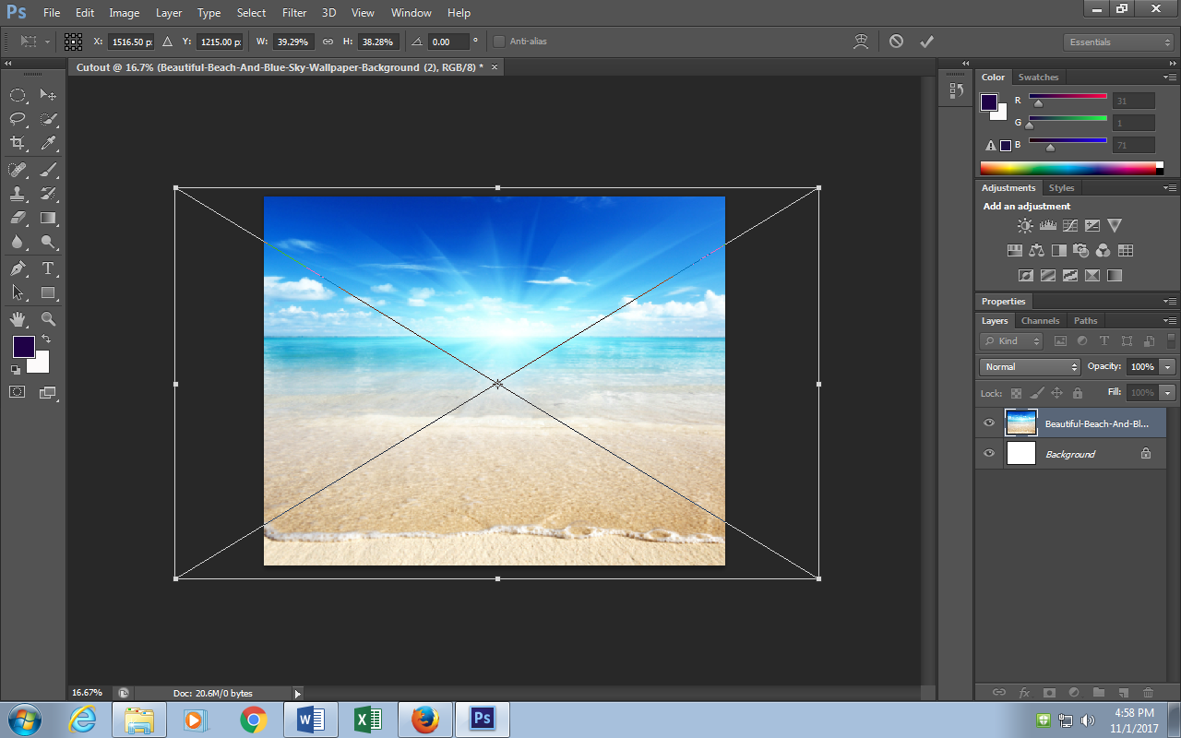
- Create another New layer the same way (layer – New – Layer) Name this “Leo”
- Go to File – Place and this time choose the Leo Pic from STUCOMMON- hit enter
- Turn Off the eyeball of the beach layer
- Go to the quick select tool
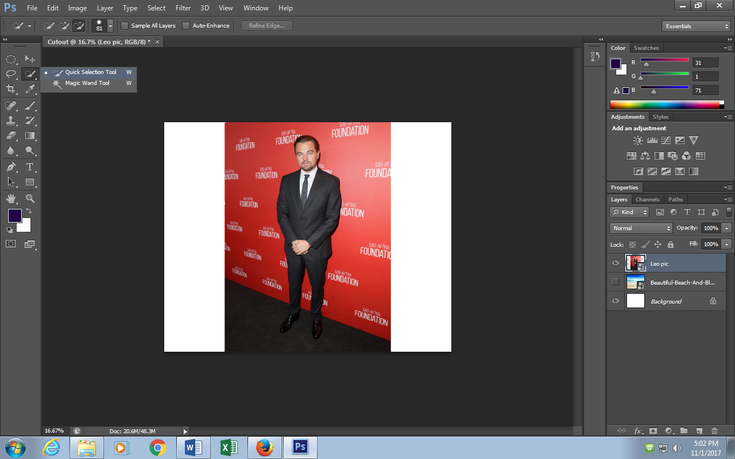12) Zoom in and use the quick select tool to get a good selection of Leo. Make sure to go back and forth between “add selection” and “delete selection” The keyboard shortcut for this is to hold ALT while brushing over the unwanted selection. Remember to zoom in and out (CTRL + and CTRL -) and to change the size of your brush to help in the selection
13) Once selection is perfect make sure to save your selection: Select – Save selection
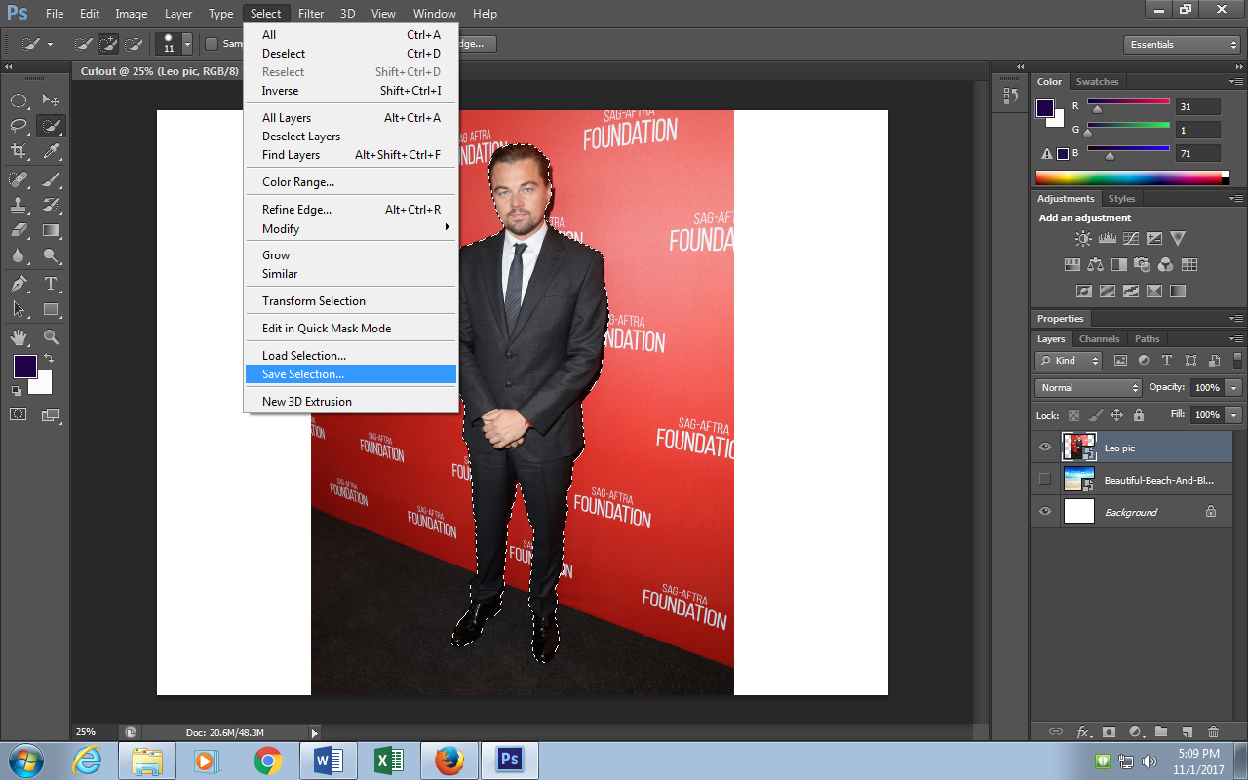

14) Title it “Leo” and hit enter
15) Click on “Refine Edge” select to have selection on black background from the drop down menu

16) Click on the refine radius tool
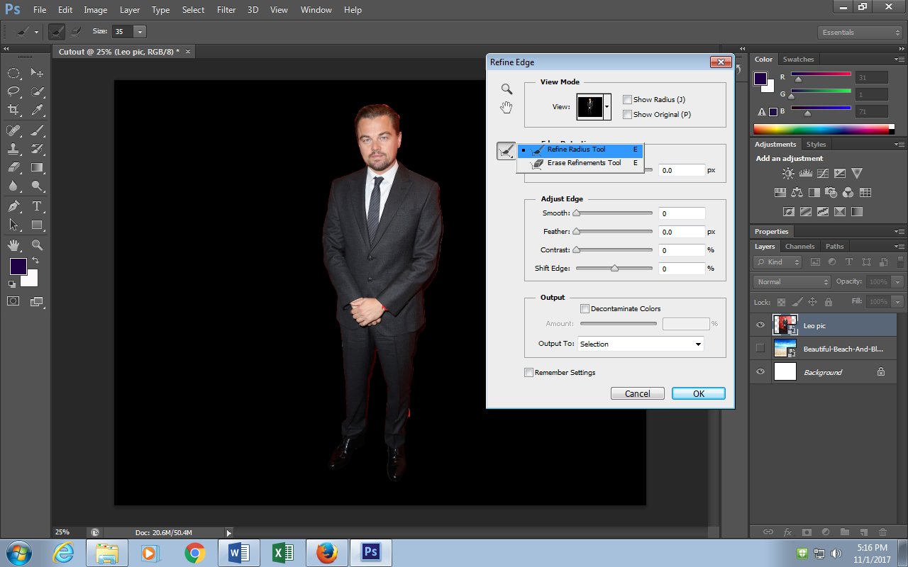
17) Zoom in and brush over the edges if the figure to tighten up the selection and make it less chunky and pixelated. If you check “decontaminate colors” some of the color issues of the selection with go away (the red in this case)

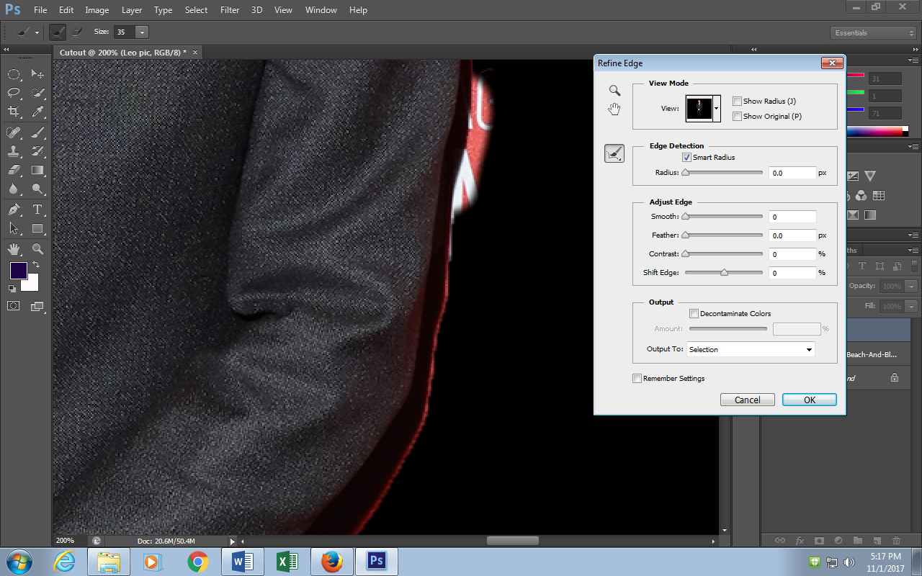
18) From the dropdown menu select to “New Layer with Layer Mask”
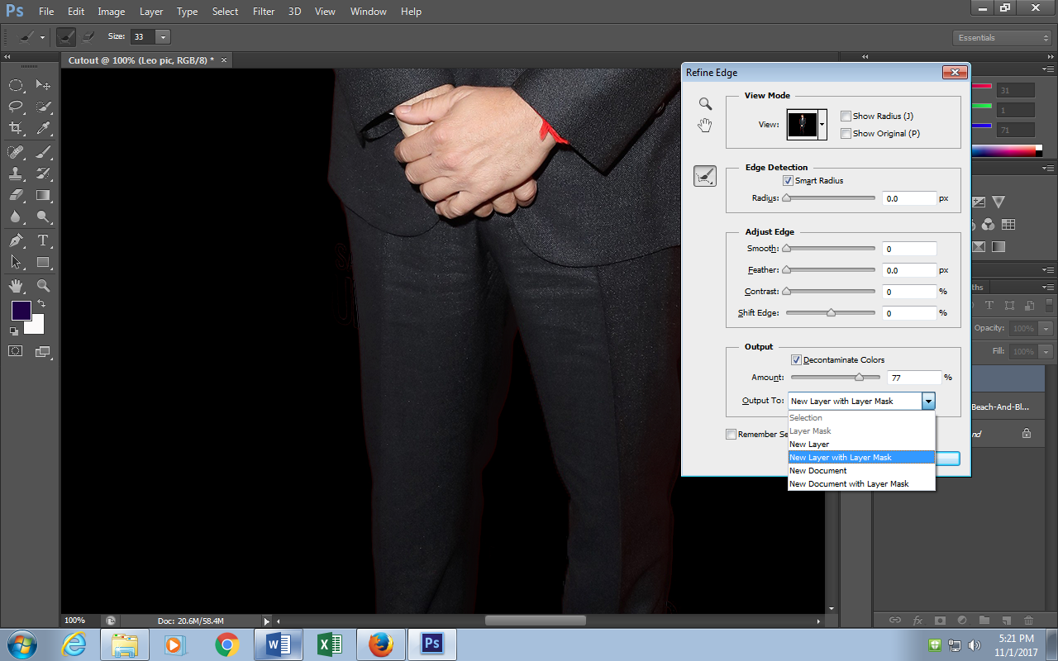
19) Turn Eyeball back on the beach layer
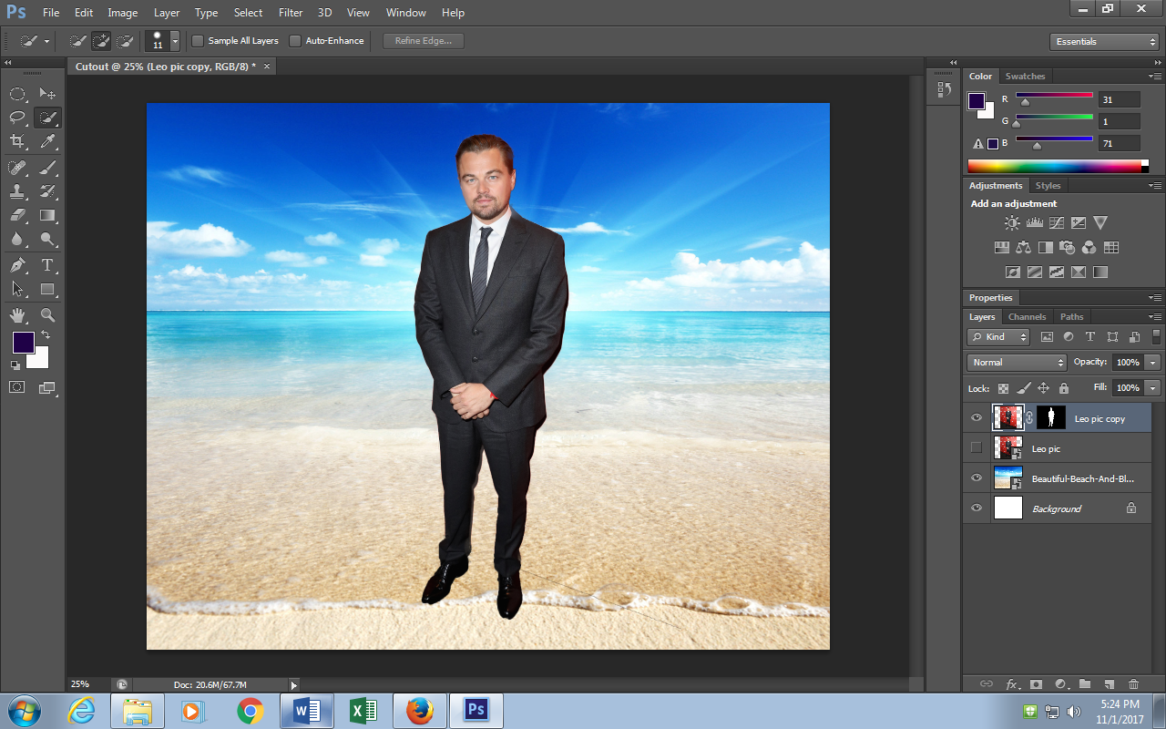
20) Use the “Move Tool” to resize and r- position. Make sure the “show transformation controls” box is checked. Also when resizing make sure to hold “Shift” to keep proportions contained.
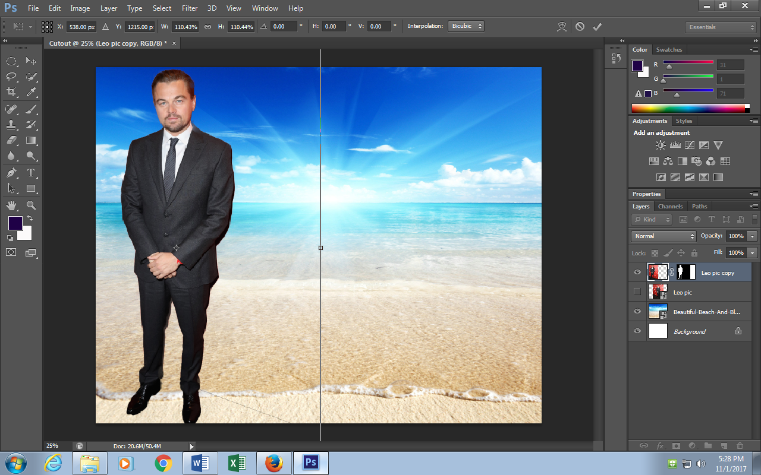
21 You can duplicate and transform the layer multiple times by making sure you are on the “Leo” layer then creating a duplicate layer and using the move tool to move and transform each layer.
