Photo Unit 1 review Guide: Name: ___________________________
Composition Rules and the Photoshop workflow

For questions 1-7 use words or drawings to define the Rules of composition.

- Rule of 3rds

- Leading lines

- Symmetry and Pattern

- Depth of Field

- Framing

- Bird’s eye view

- Worm’s eye view

8)What does it mean to crop an image?___________________________________________________
What are the 2 things to crop for? ___________________________________
9)The actual dots of color/light that makes up a digital image are? __________________________

10) The amount of those “dots” in a square inch is the photo’s____________________________?
11) For this class we set the above answer to ________________________
12) The compositional tool used in a camera to frame the image is called the ________________________
13) When taking a photograph of something moving you want to make sure you leave some ___________________________________________ in the direction the object is moving.
14) In Photoshop, ______________ are used to work on individual editing steps. This separates the steps so you can work on one thing without effecting another.
15) Saturation is ___________________________________________
16) Resolution is __________________________________
17) Standard print sizes are _________________________________
18) a highlight is ________________________________
19) a shadow is________________________________________
20) a highlight so bright it is totally white is called a ___________________________________
21) When you press the button that takes the picture you are opening the _____________________
22) What are the 7 steps in the Photoshop workflow? Make sure you know the proper order.
1)
2)
3)
4)
5)
6)
7)

Define the following terms

Still life __________________________________________________________________________________________
Portrait __________________________________________________________________________________________
Perspective (both definitions) ________________________________________________________________________
Opacity __________________________________________________________________________________________
Text _____________________________________________________________________________________________
Font _____________________________________________________________________________________________
Contrast __________________________________________________________________________________________
Levels ____________________________________________________________________________________________
Highlight __________________________________________________________________________________________
Shadow __________________________________________________________________________________________
Midtone __________________________________________________________________________________________
Saturation _________________________________________________________________________________________
The Magic Hour ____________________________________________________________________________________
Photo reflector ____________________________________________________________________________________
Backdrop __________________________________________________________________________________________
Depth of field ______________________________________________________________________________________
Forced Perspective _________________________________________________________________________________
Explain the uses for each of the following Photoshop tools
Clone Stamp _______________________________________________________________________________________
Move tool _______________________________________________________________________________________
Lasso tool _______________________________________________________________________________________
Magnetic lasso tool __________________________________________________________________________________
Polygonal lasso tool _________________________________________________________________________________
Quick selection tool _________________________________________________________________________________
Crop tool _________________________________________________________________________________________
Eraser tool _______________________________________________________________________________________
Brush tool _______________________________________________________________________________________
Paint Bucket tool __________________________________________________________________________________
Text tool _______________________________________________________________________________________
Blur tool: :__________________________________________________________________
Gradient tool: :__________________________________________________________________
Healing brush tool: :__________________________________________________________________
Cookie cutter tool: :__________________________________________________________________
Burn tool: :__________________________________________________________________
Hue: :__________________________________________________________________
Primary colors: :__________________________________________________________________
Secondary colors: :__________________________________________________________________
Tertiary colors: :__________________________________________________________________
Analogous color scheme: :__________________________________________________________________
Complimentary/contrast color scheme:__________________________________________________________________
Know Photographic, Lighting, Composition, focus techniques for Still Life and Portraiture
If you have a blurry photo the 3 possible problems are? ____________________________________________________
What is the best light for Portraits? _____________________________________________________________________
What is the worst time of day to take outdoor portraits? ____________________________________________________
Does natural or artificial light make more flattering portraits _________________________________________________
When creating a still life how would you arrange lighting to give a dramatic feel? __________________________________________________________________________________________________
Why is posing and facial expression important to think about when taking a portrait? __________________________________________________________________________________________________
Why are plain white walls often problematic in Photography? _______________________________________________
How do clothes and backgrounds relate in portrait photography? __________________________________________________________________________________________________
What are the four components of poster design? And describe the important component of each. 1)________________________________________________________________________________________
2) _______________________________________________________________________________________
3) _________________________________________________________________________________________
4) ____________________________________________________________________________________________

Label white orientation is landscape and which is Portrait

_____________________ ___________________________
In the following questions state which principle of design BEST fits the photo and explain WHY.
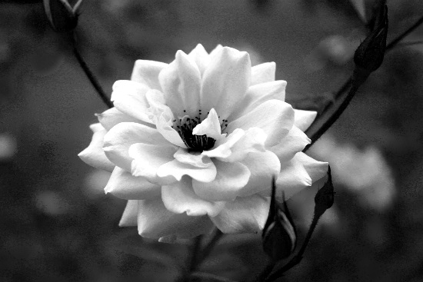
Principle: ______________________________
Why? __________________________________
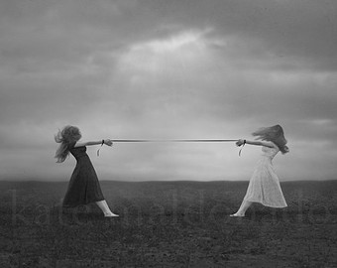
Principle: ______________________________
Why? __________________________________
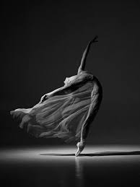
Principle: ______________________________
Why? __________________________________
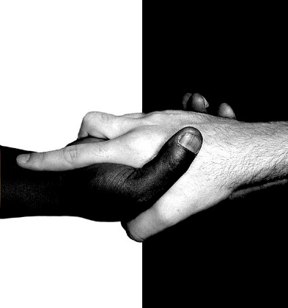
Principle: ______________________________
Why? __________________________________
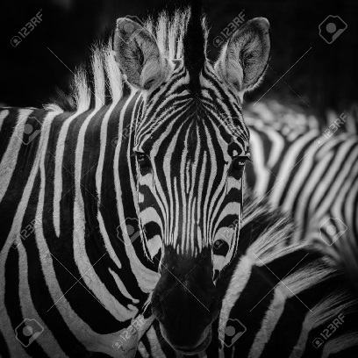
Principle: ______________________________
Why? __________________________________

What is the difference between a snap shot and a professional looking photograph? What can a photographer do ensure their photograph does not look like a snap shot.

________________________________________________________________________________________________________________________________________________________________________________________________________________________________________________________________________________________________________________________________________________________________________________________________________________________________________________________________________________________________________________________________________________________________________________________________________________________________________________________________________________________________________________________________________________________________________________________________________________________________________________________________________________________
_______________________________________________________________________________________________________________________________________________________________________________________________________________________________________________________________

