Step 1: Open a new blank file
Step 2: name cutout text portrait. Make sure the “preset” is set to “photo” and you have chosen either “landscape 8x10” or “portrait” 8x10 (or any other size that you want)
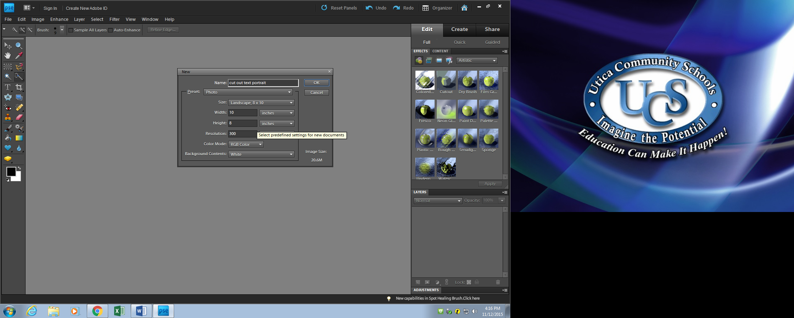
Step 3: Create a new layer
Step 4: Name the layer “cutout” 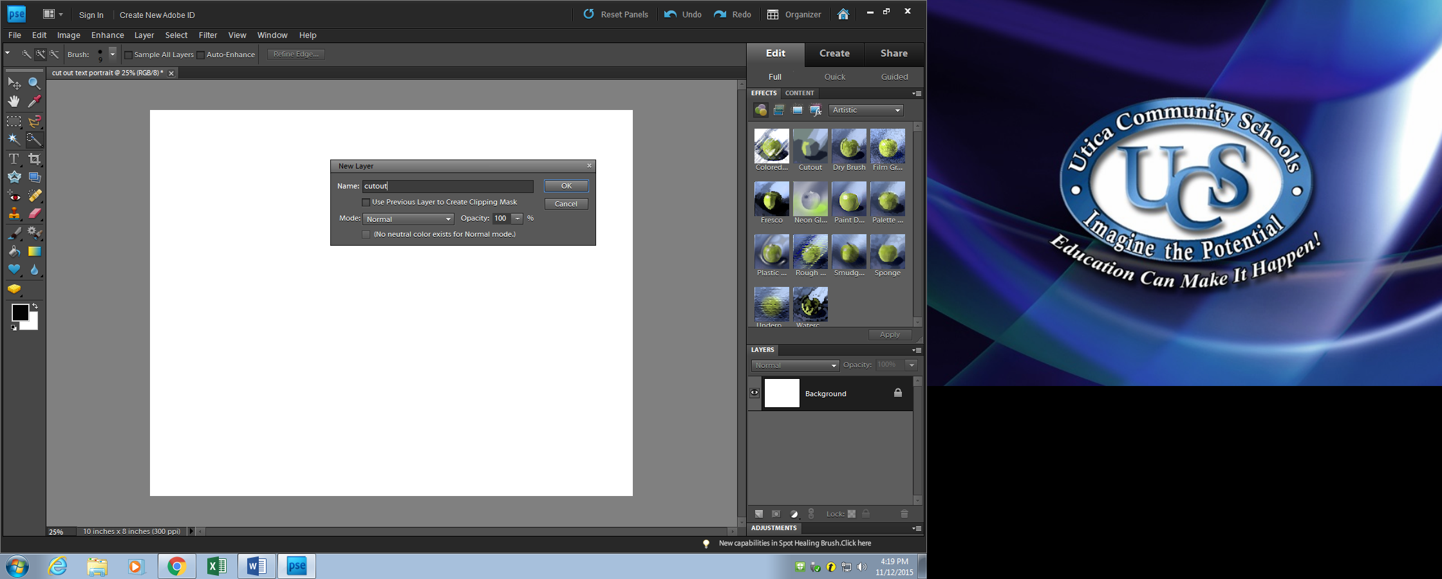
Step 5: go to “file” and select “place”
Step 6: select the image you wish to place
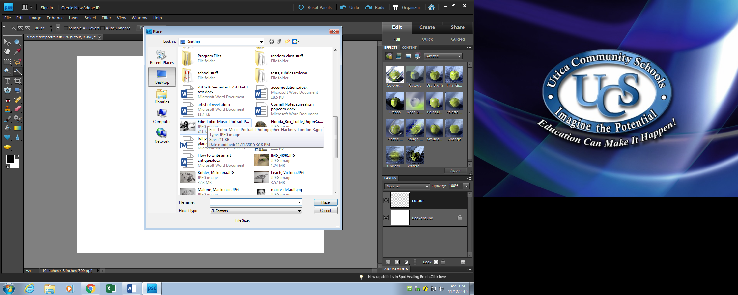

Step 7: Hit enter if it is arranged on the page how you want, if not move it and resize so it fits.
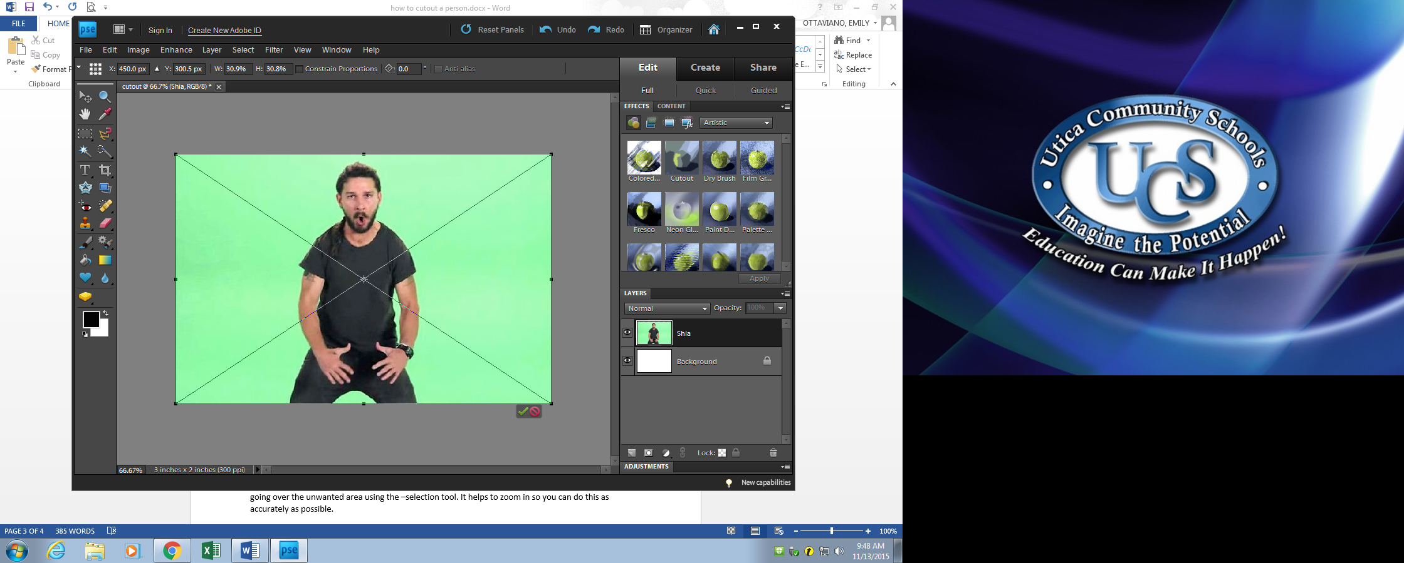
Step 8: Select the “quick selection” tool from the tool box
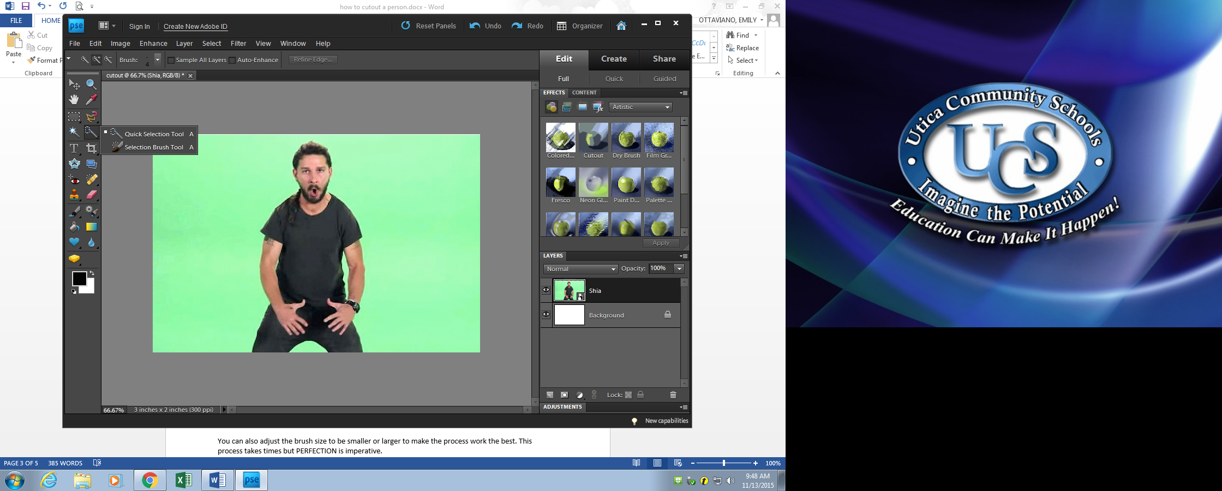
Step 9: Drag it along the edges of the person and guitar. You are trying to select only the figure and guitar.
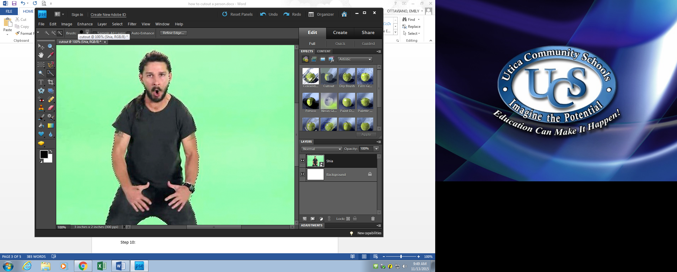
Step 10: If and area you do want is selected, you can use the – selection tool to unselect the area by going over the unwanted area using the –selection tool. It helps to zoom in so you can do this as accurately as possible.
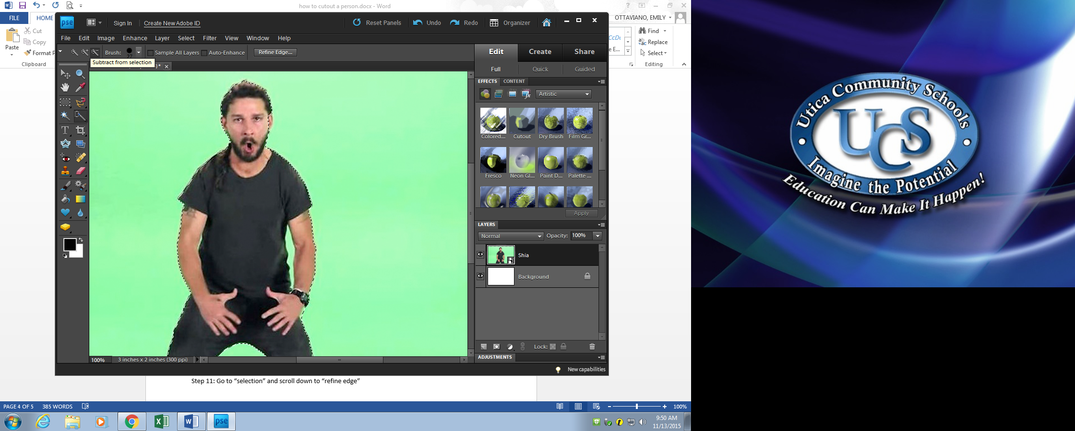

You can also adjust the brush size to be smaller or larger to make the process work the best. This process takes times but PERFECTION is imperative.
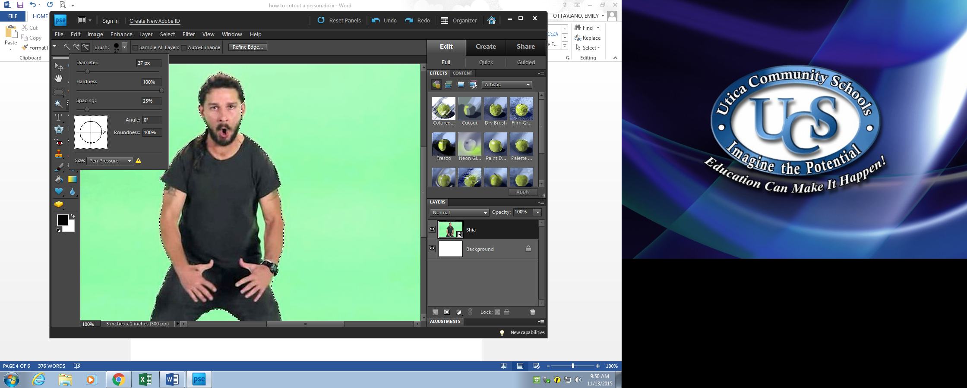
Step 10: When the image is perfectly selected. Click on go to “selection” select “refine edge” and adjust the feather so that the selection does not look like an obvious cutout
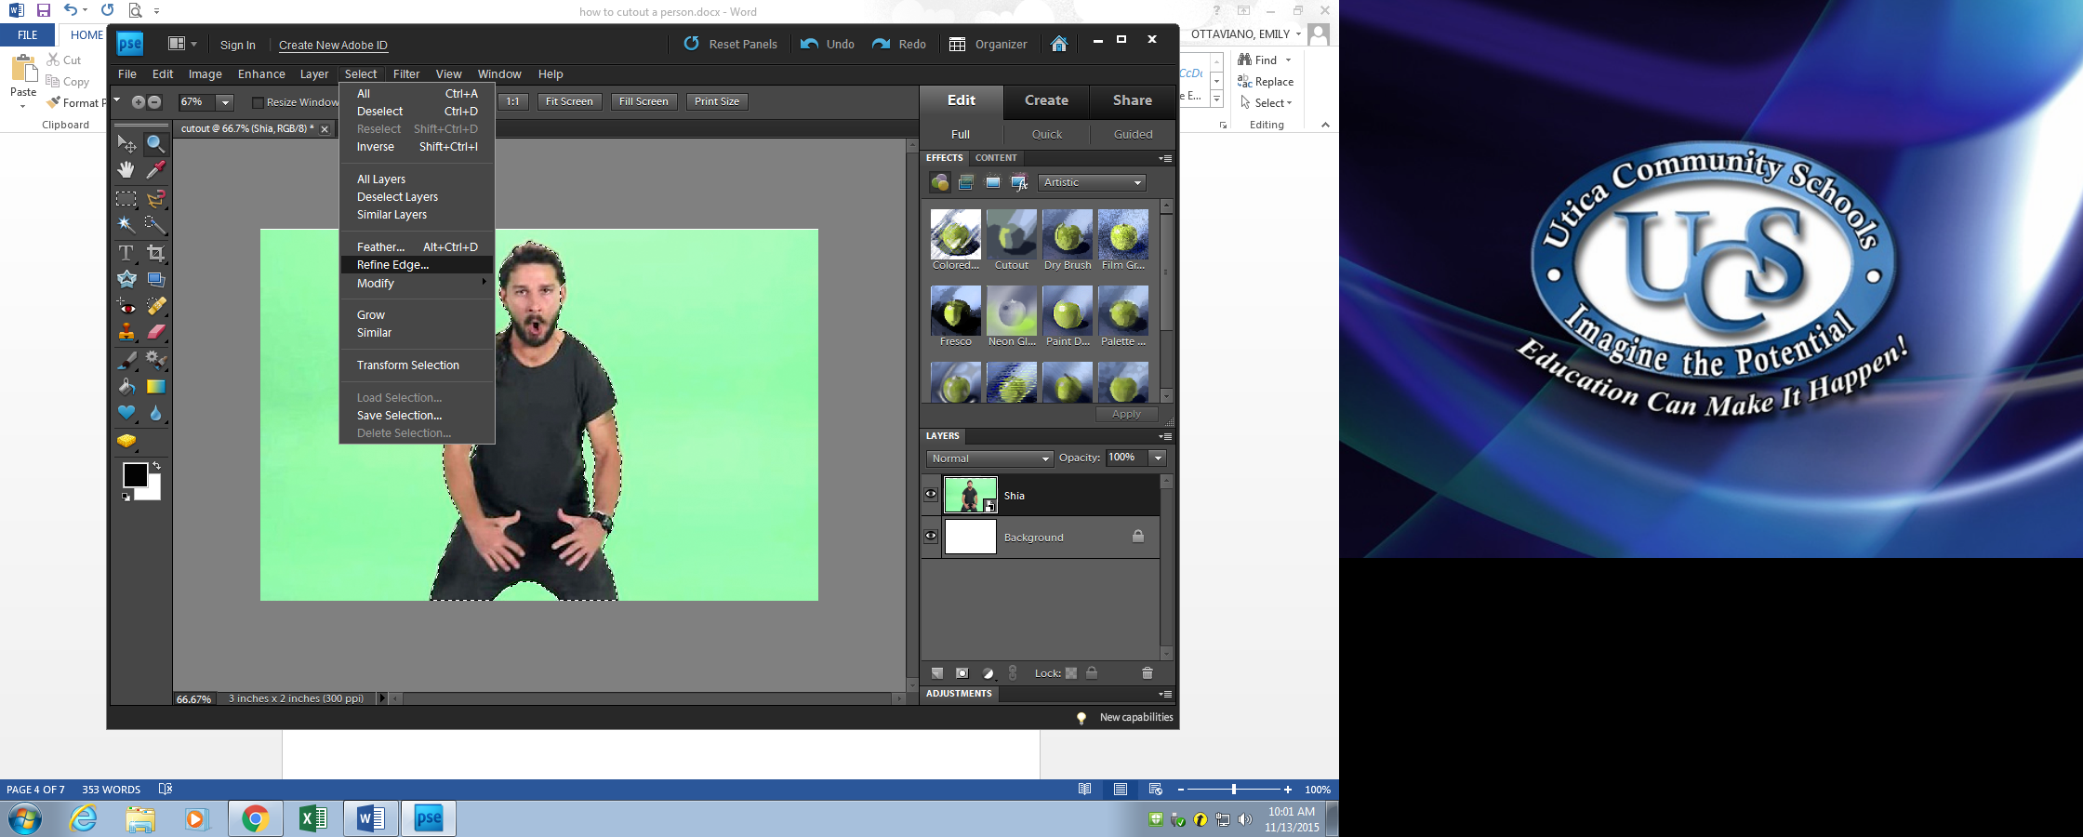
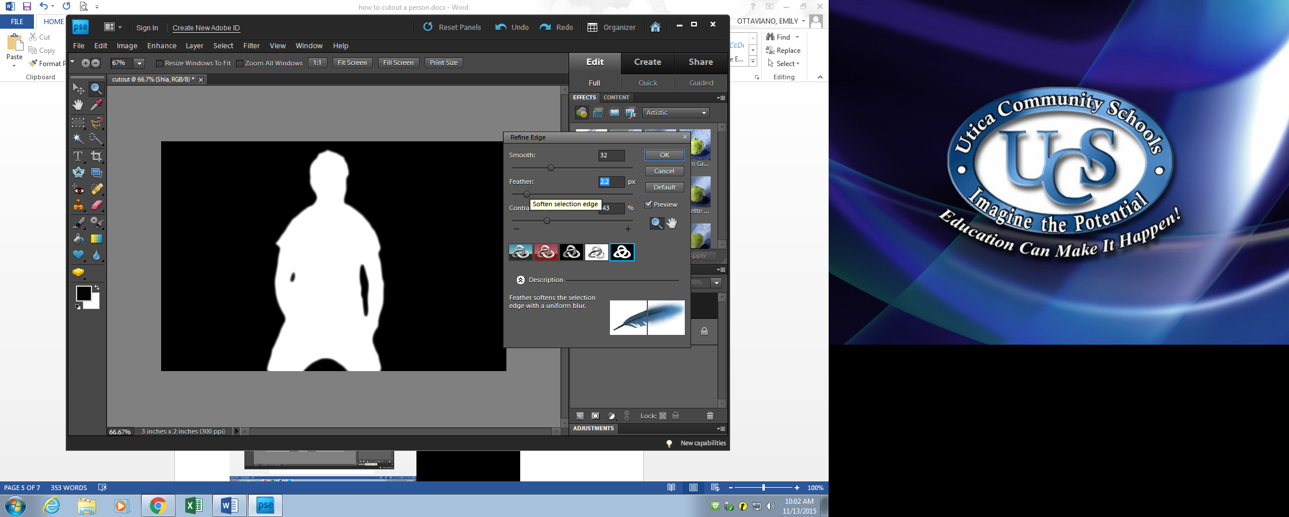
Step 11: select “create layer mask” located at the bottom of the layers window

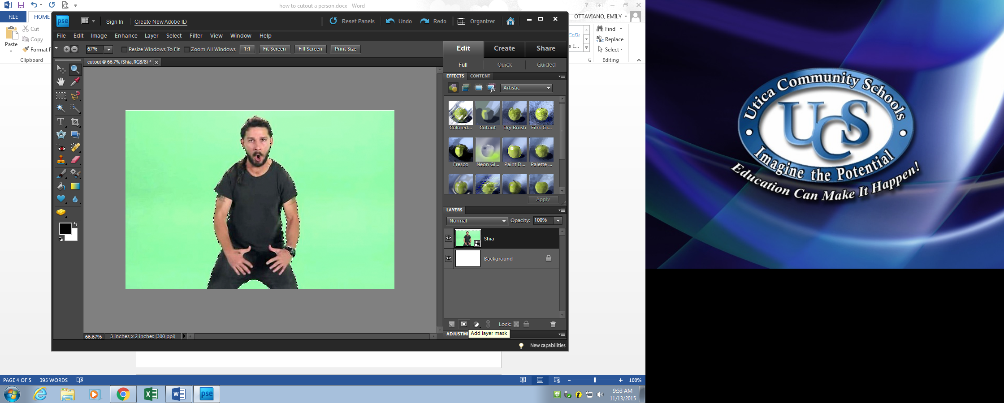
Step 12: Create new layer name “background”
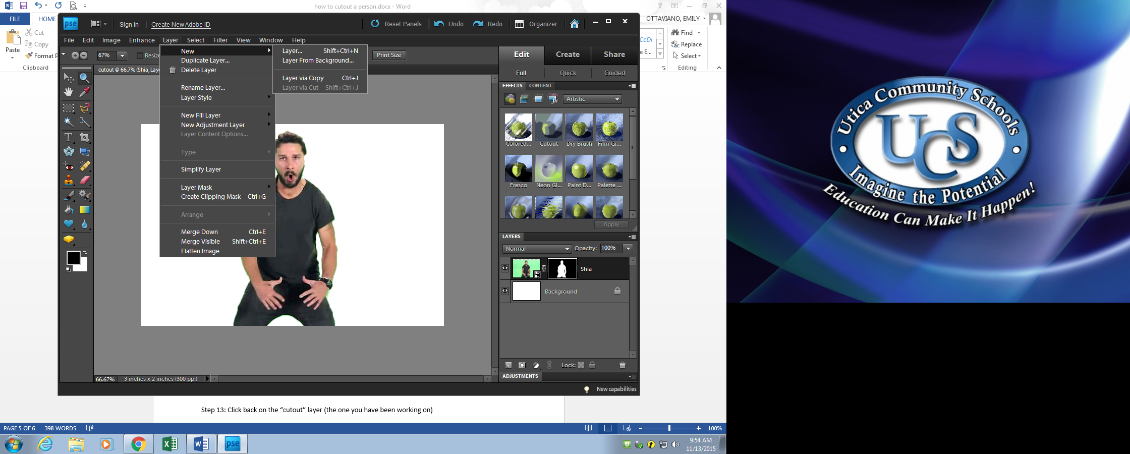

Step 12: : either go to “file” “place” and select the photo you want to use as your background or use the paint bucket tool to create a solid color layer. (Make sure you are working on the layer you just created)

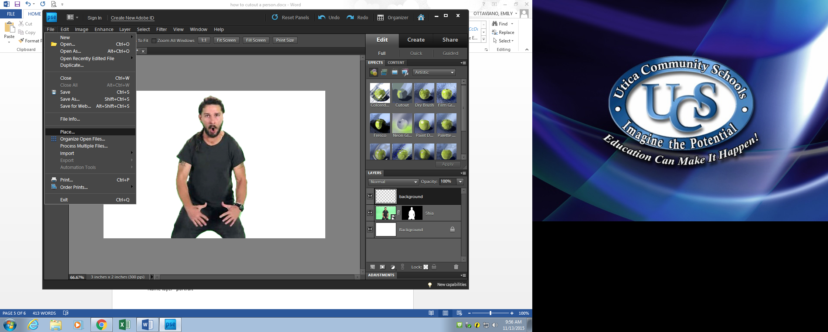
Or
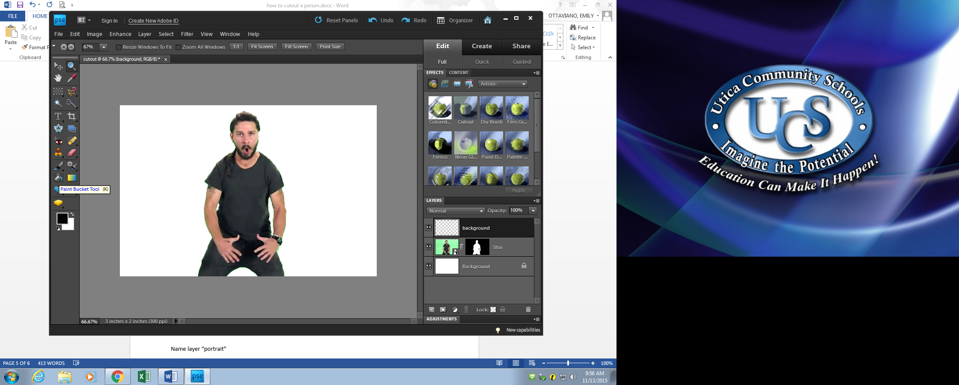

The photo you selected will pop up, or the color color will fill the space
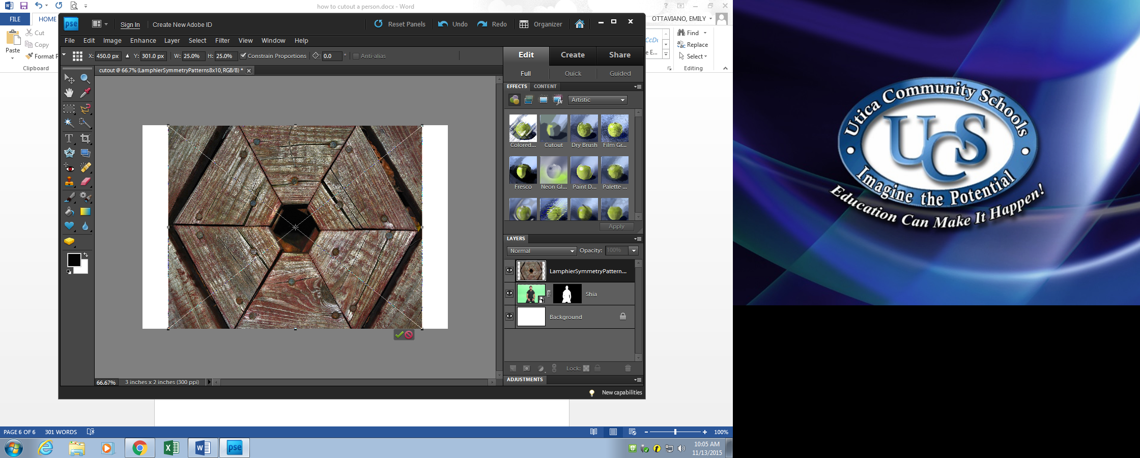
or
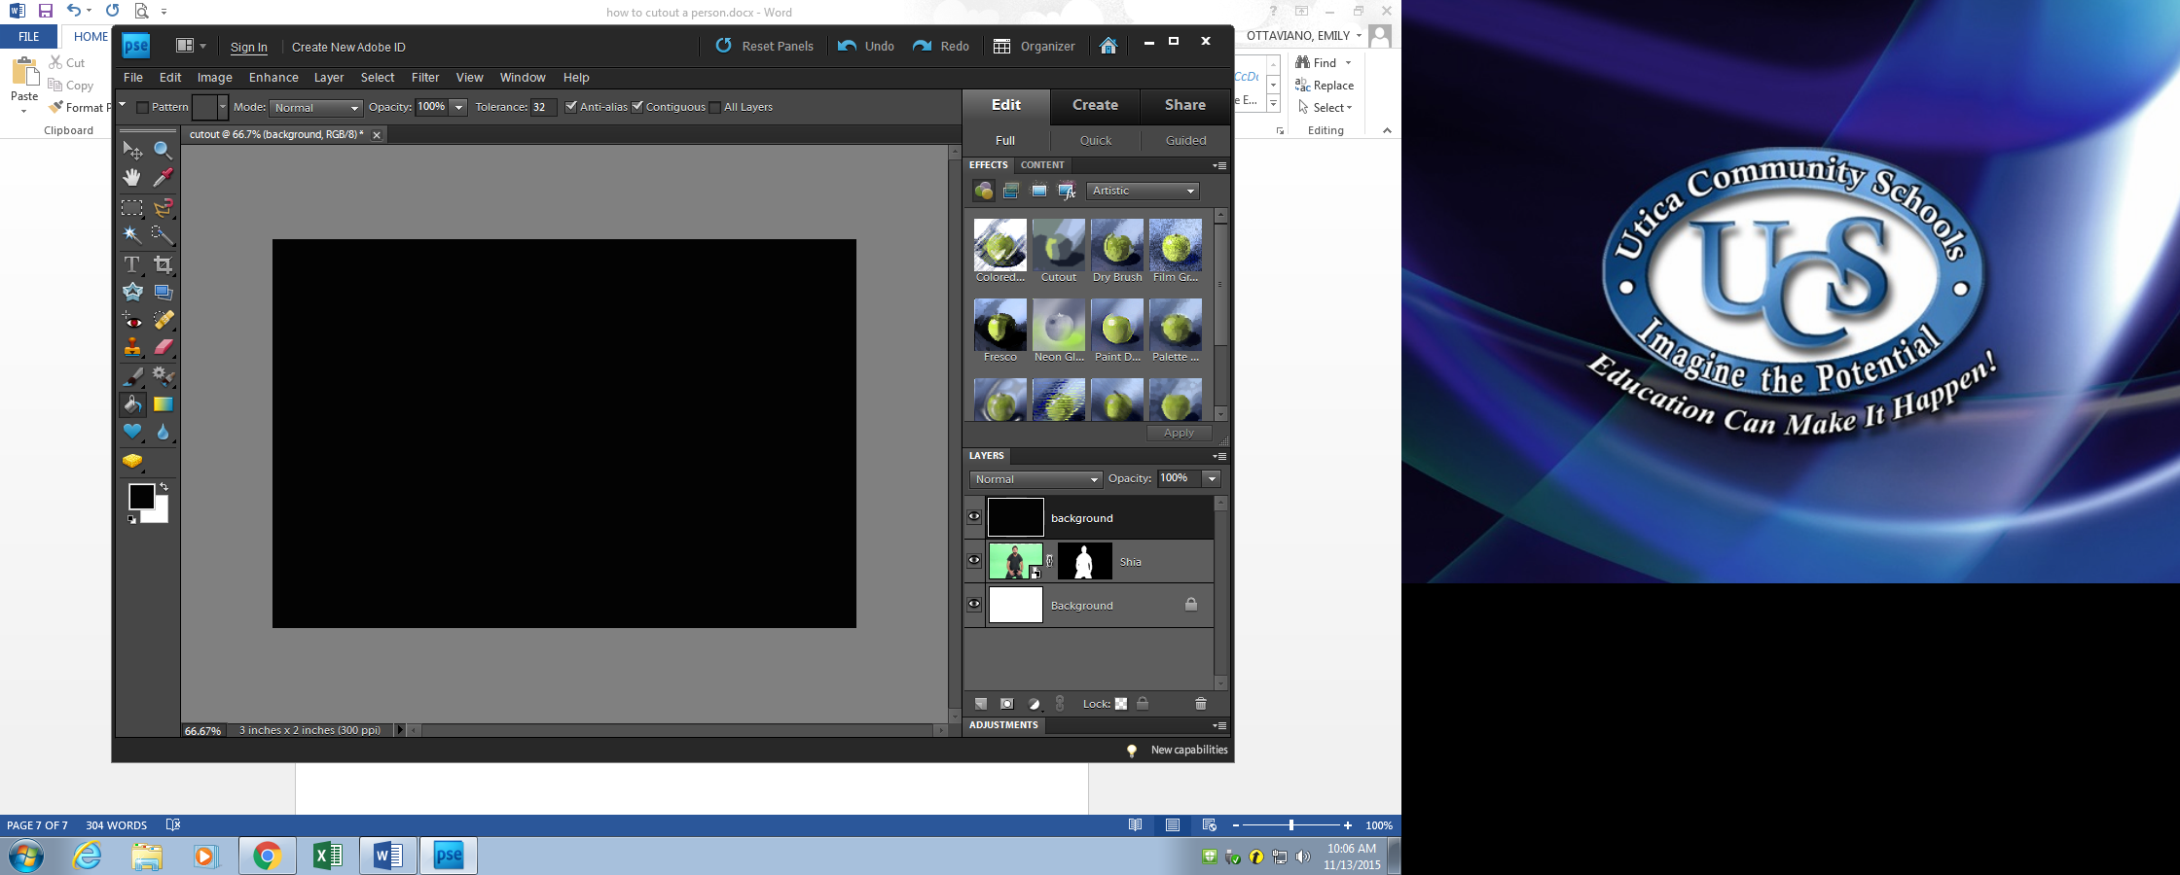
Step 13 : click on the layer with the person in it, hold down the clicker and place above the “background” you just created. This will place your person on the background.
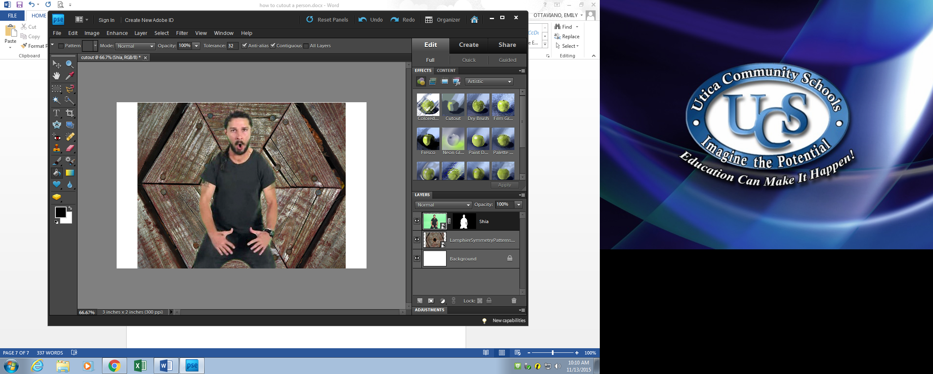

You can then click on the “move tool” to put the person where you want
