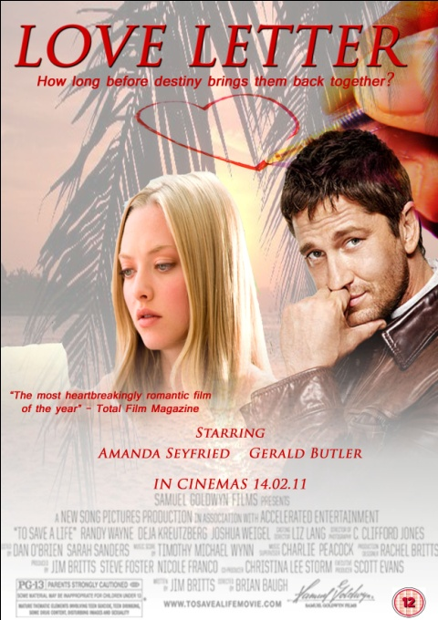
CAN YOU DESIGN THIS POSTER?

- File, New – blank file and choose International Paper and A4 to create a poster shape.
- Go to File, Save As, and save it with your name as the title movie poster.psd on your desktop

- Go to File and Place and find the picture of the beach ( in movie poster file) and choose it. Go to image – transform - Free Transform (image- transform- free transform) to drag it to fit the poster like the picture below. Right click on the LAYER containing the beach and choose simplify (see screen shot)
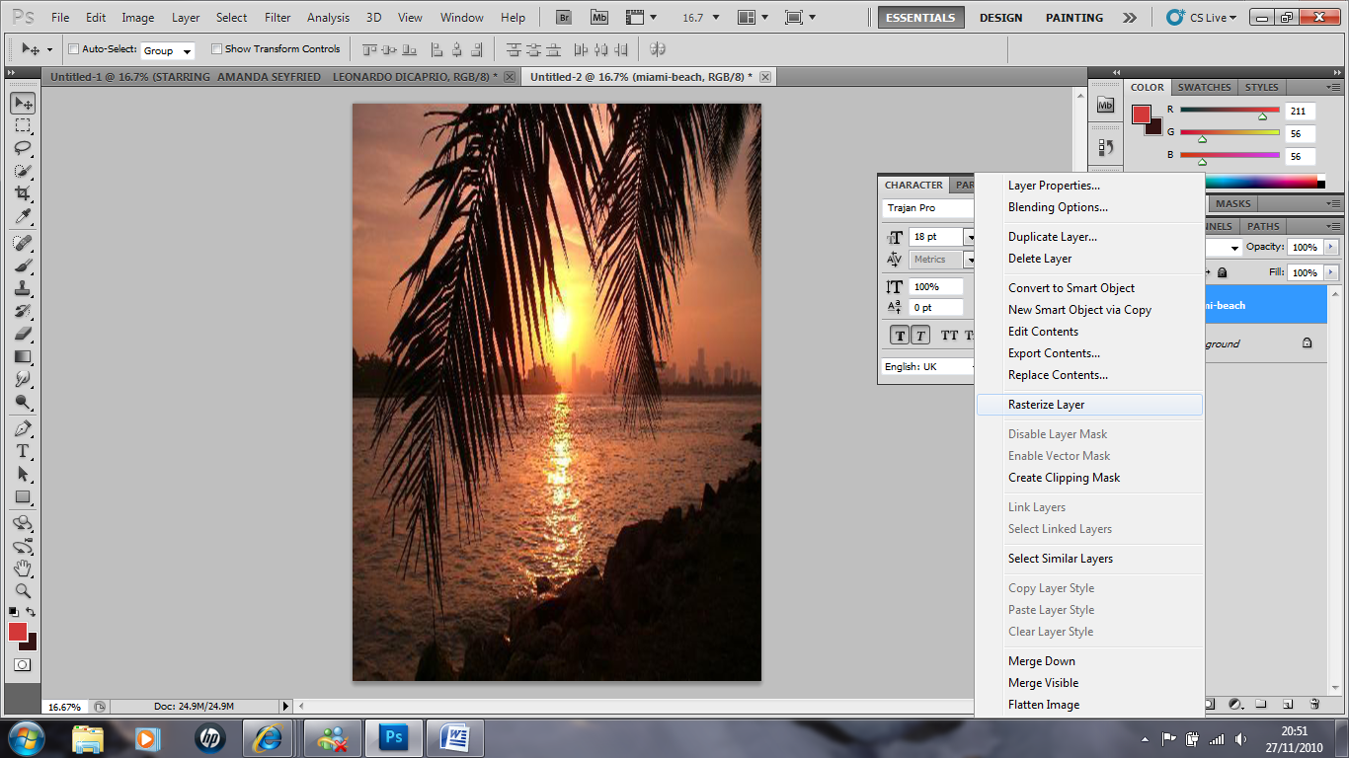

Amanda Seyfried. Choose that picture and move it around and resize it so it looks like this.

- Underneath the box containing your layers, click on the icon that is New Layer Mask
Then choose the Gradient Tool from the tool bar. Check that your settings at the top of the screen look like mine in the shot below.

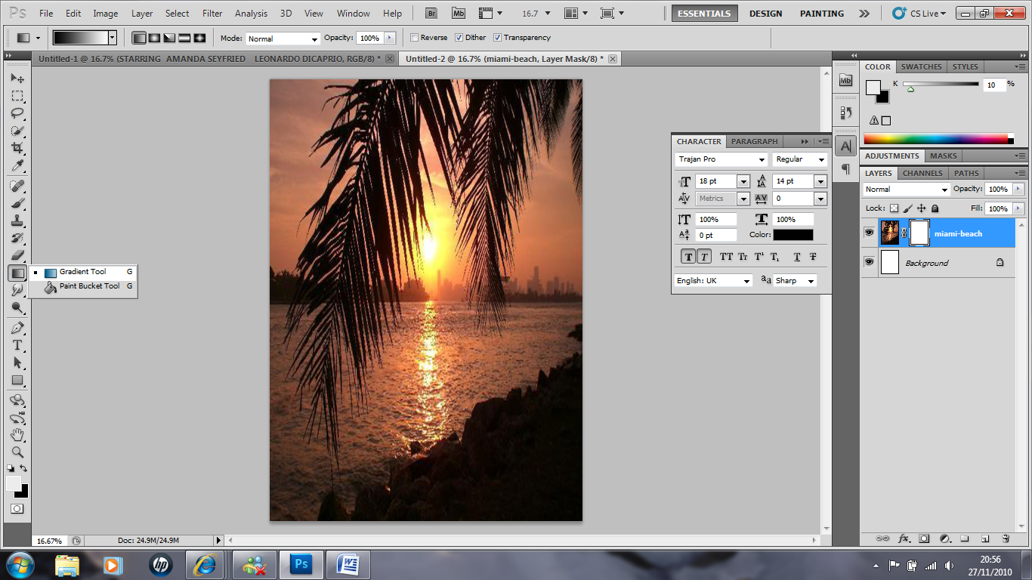

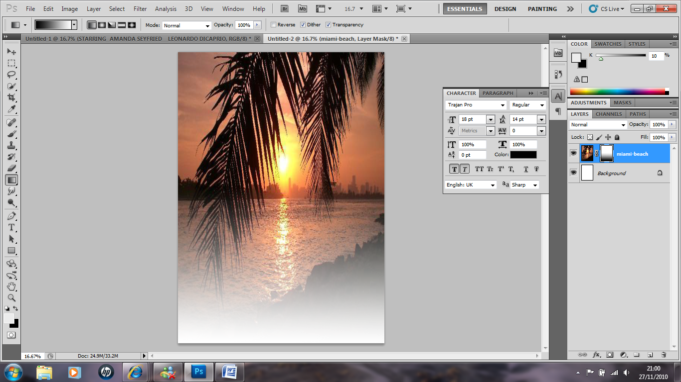
Now click and drag a line from the bottom of your film poster to half way up (near the city). It should now look like this (see below)

- Now you are going to make the picture a little more see through and faded by choosing the OPACITY option on the right hand side, and changing it to about 40%. Now it should look like this

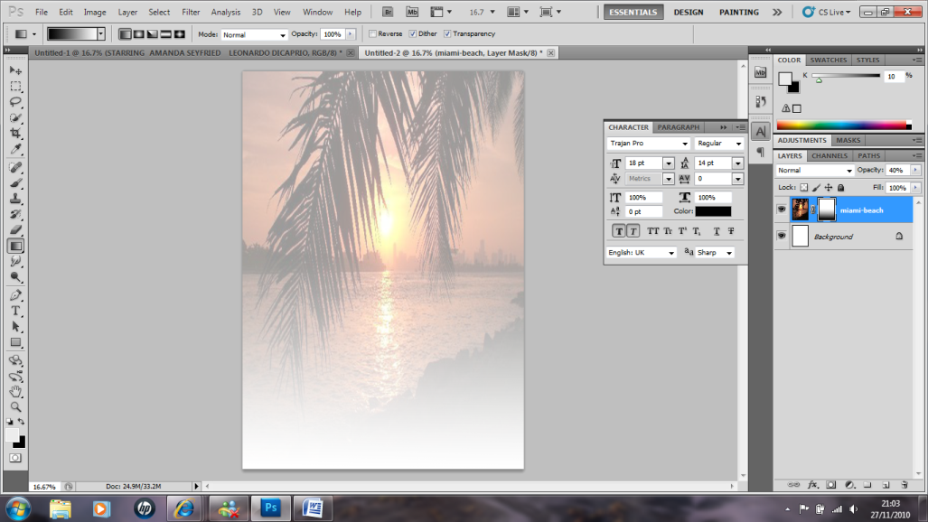

- Create a new layer. Now go to layer - new layer name layer – Amanda - File again and Place, and find the picture of Amanda Seyfried. Use Edit and Free Transform to make her the right size and move her to the left hand side of the poster. Right click on her layer and choose simplify again to allow you to edit her picture.
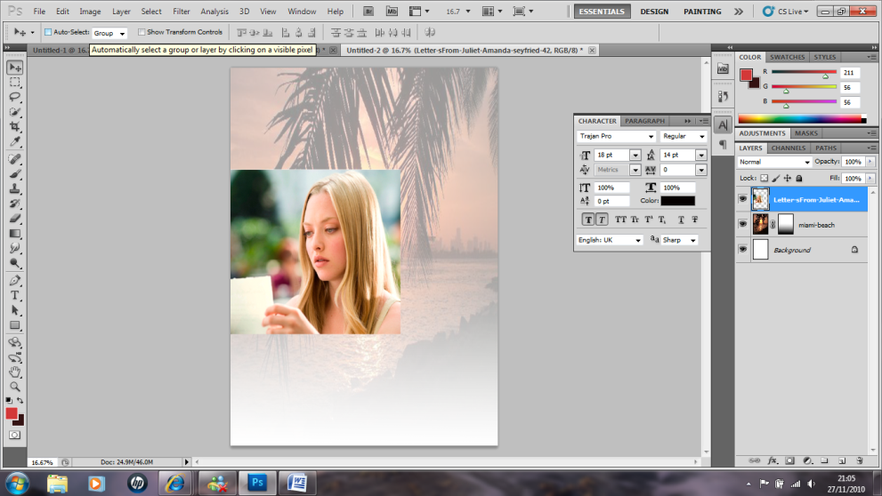

- Use the Quick Selection Tool to help you to select areas behind (background) Amanda and use backspace to delete them. You want to be left with just Amanda holding the letter. If you find there are small parts of the background you can’t seem to select, use the Eraser tool and rub over them carefully to rub them out. It should now look like this. Remember to zoom in when selecting to get the best selection. Press Ctrl d to deselect or go to select – deselect
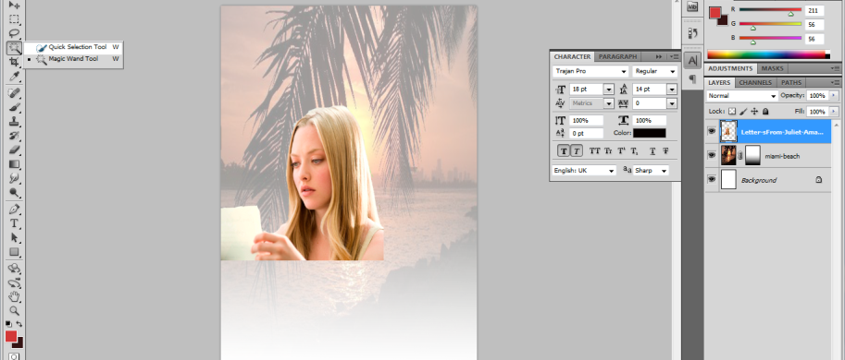

- You are now going to repeat the process of fading out the bottom half of the picture like you did for the beach. On your layers box, make sure the Amanda layer is selected, click on the icon that adds a Layer Mask. Go to the Gradient Tool and draw the line from the bottom of Amanda, about half way up her. This is what it should look like now!
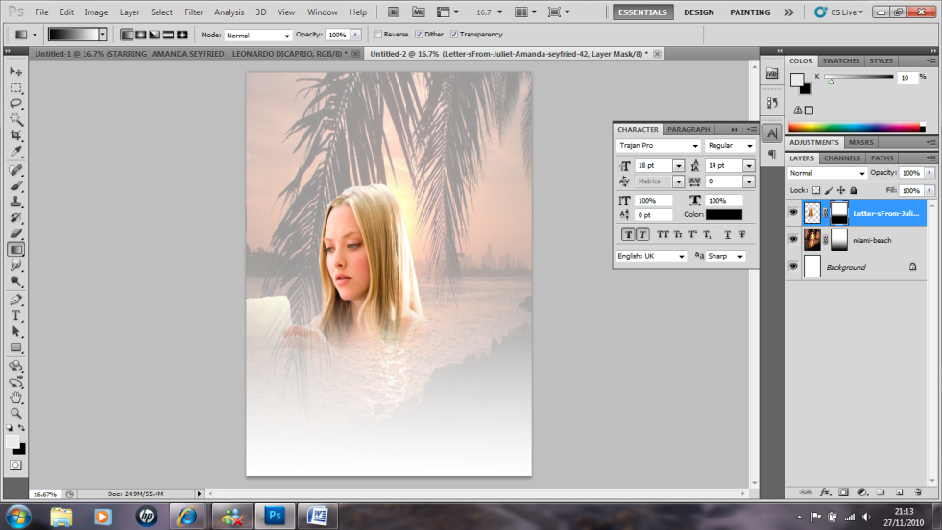

- Now go to new layer – name layer Gerald and go to File and Place and find the picture of Gerald Butler. Using Edit and Free Transform, re size him and move him around until he looks like this. Right click on his layer and choose simplify.
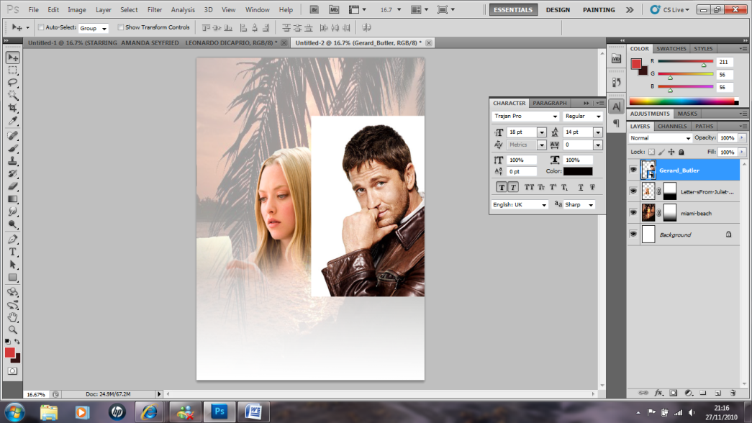

- Repeat everything you did with Amanda’s picture, to Gerald’s picture. Use the Quick Selection Tool to cut him out, and then add the Layer Mask, and then use the Gradient Tool to fade up the bottom half of his picture. Remember you can use the move tool on any layer to move it around the poster.
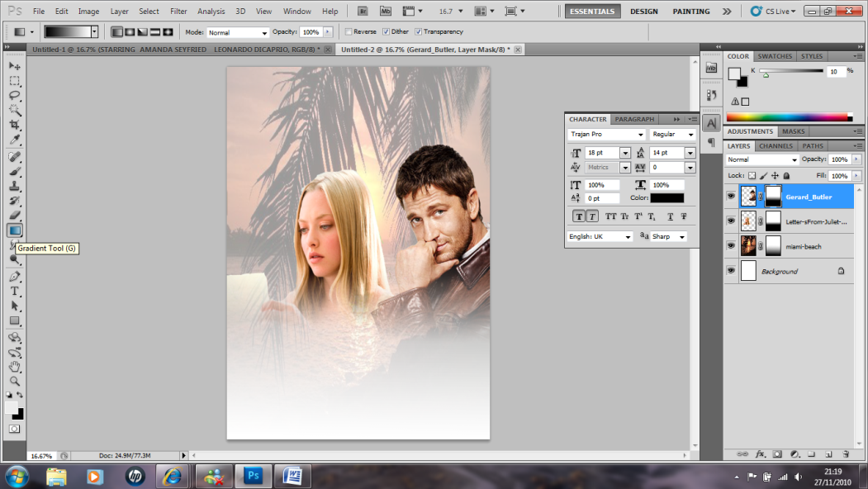

- Go to new layer – name heart and go to File and Place and choose the picture of the hand drawing the love heart. Resize it and move it around so it looks like this. Right click on the layer and choose simplify it again.
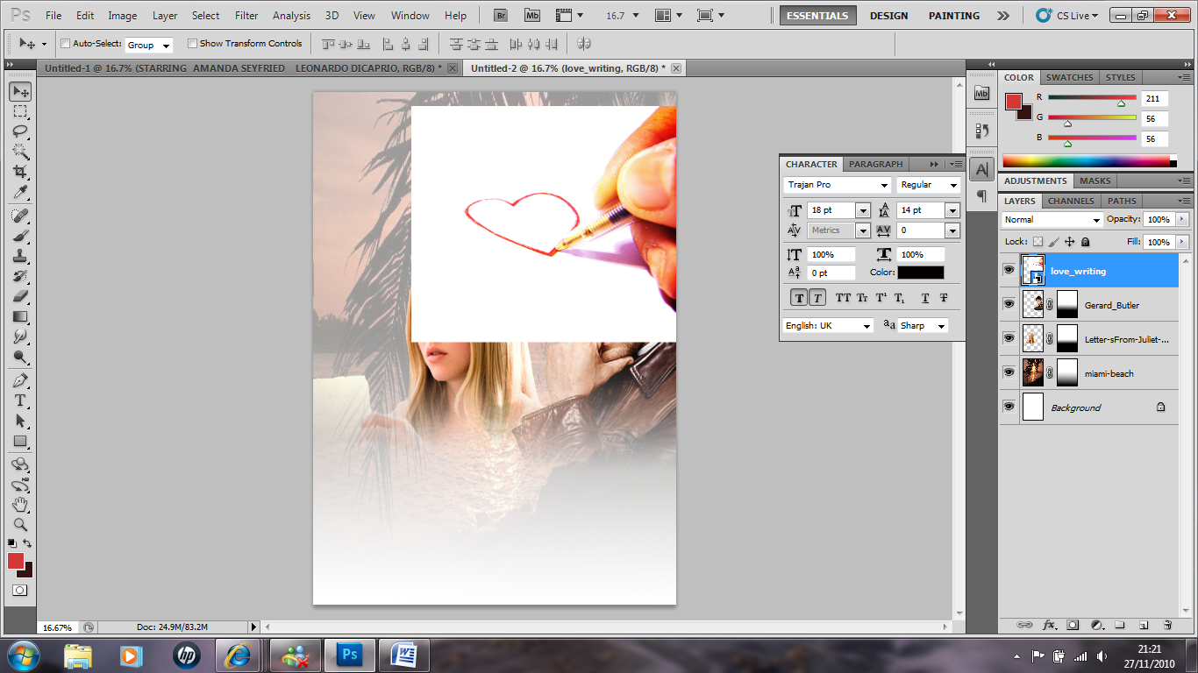

- Stay selected on that layer, and above your layers box, change the word Normal by dropping down the box and choosing Multiply. The white background should disappear leaving just a hint of the picture. You may need to move the picture around slightly to ensure we can see the pen / heart etc..
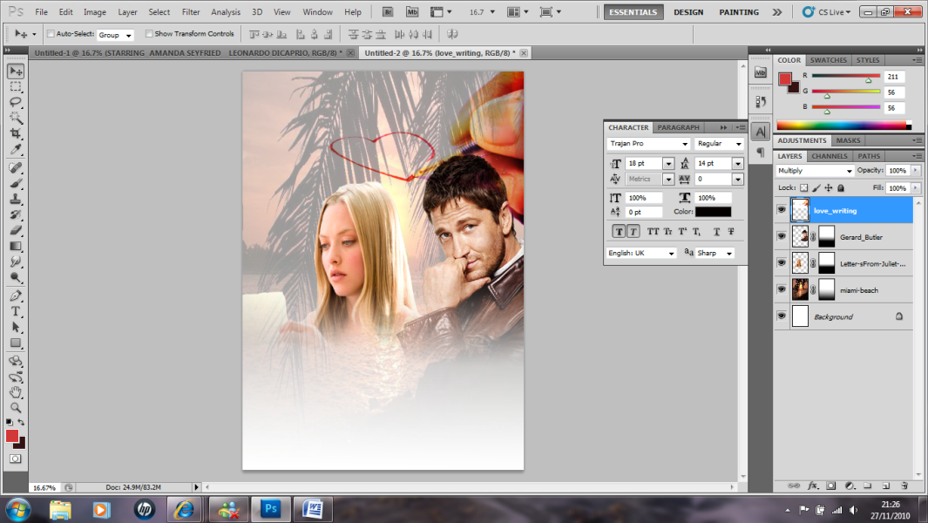

- Now go to new layer – name it credits and go to File and Place, and choose the picture of the credit block. Resize it so it covers the bottom of the poster. Add in the Film Certificate as well.
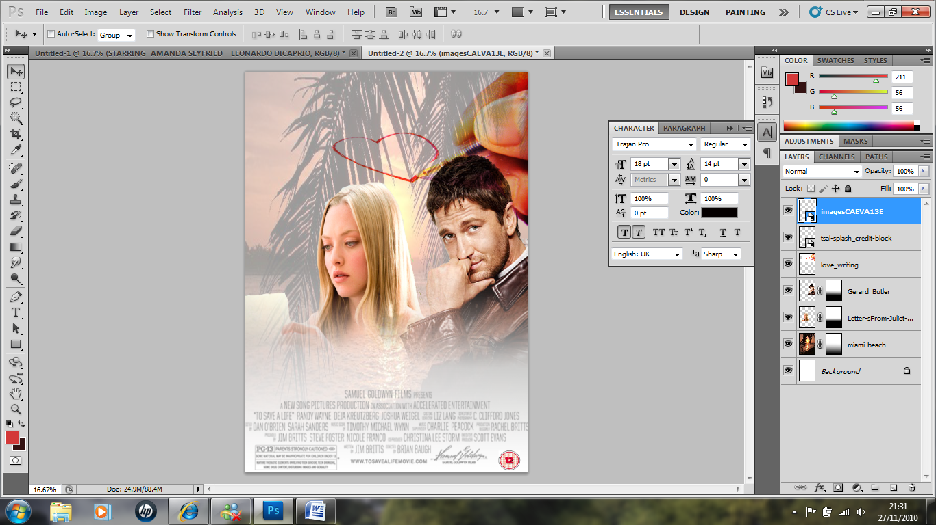

- Now its time for text! Click on the T (Text) tool and drag out a text box at the top of your poster. Click on the colour box at the top and choose a dark red colour. Choose 72pt font size, and the Trajan pro font. Choose Italics and Bold if you want. Write the title LOVE LETTER.

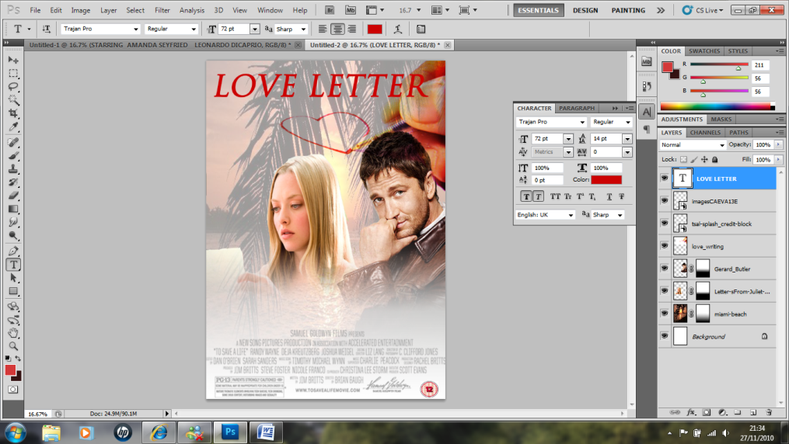

- Now use the drop down menu in the style box. Click on the double arrow and select drop shadows. Choose “hard edge”. Your title should become clearer and bolder. Click OK.
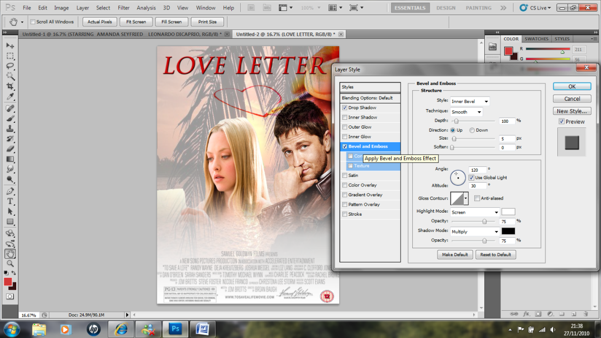

- Using the T (Text) tool again, drag out another text box and put in your actors names. Use the same font, but in a smaller size (18). Write Starring Amanda Seyfried and Gerald Butler In Cinemas 12.02.11
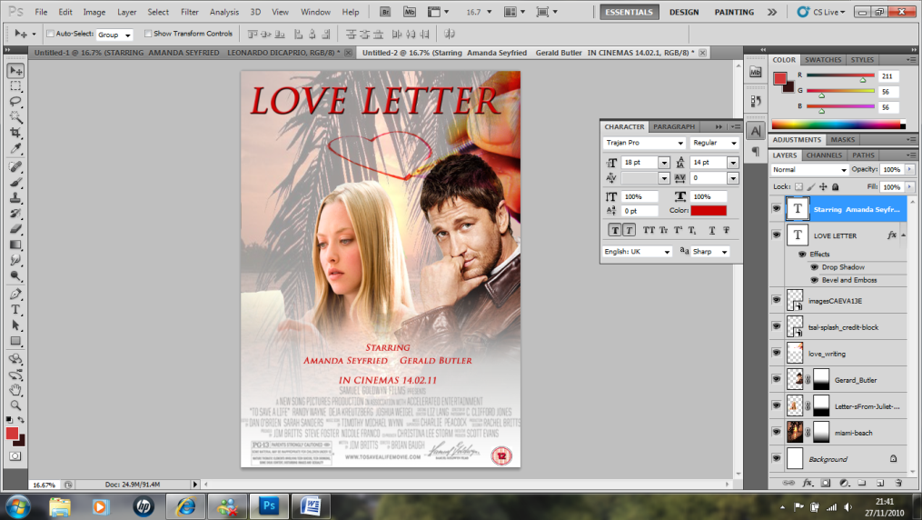
2

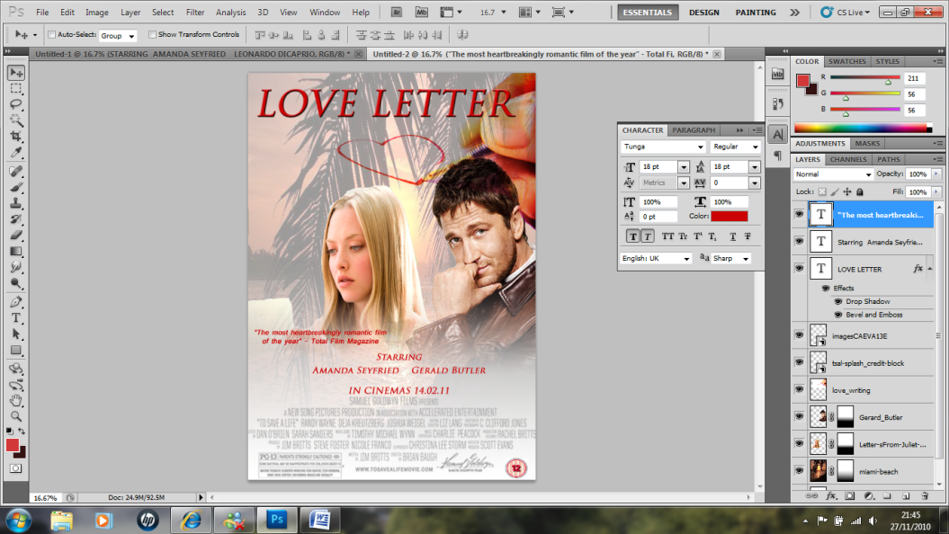
- Now add in another Text Box, and ues the Tunga Font to write a quote about the film. Mine says “The most heartbreakingly romantic film of the year” says Total Film Magazine. Place it above the actors names on the left hand side somewhere.

- Now add in one more text box to go just under the title and write in a Tag Line using Tunga font in size 24 again. Mine says, “How long before destiny brings them back together?”
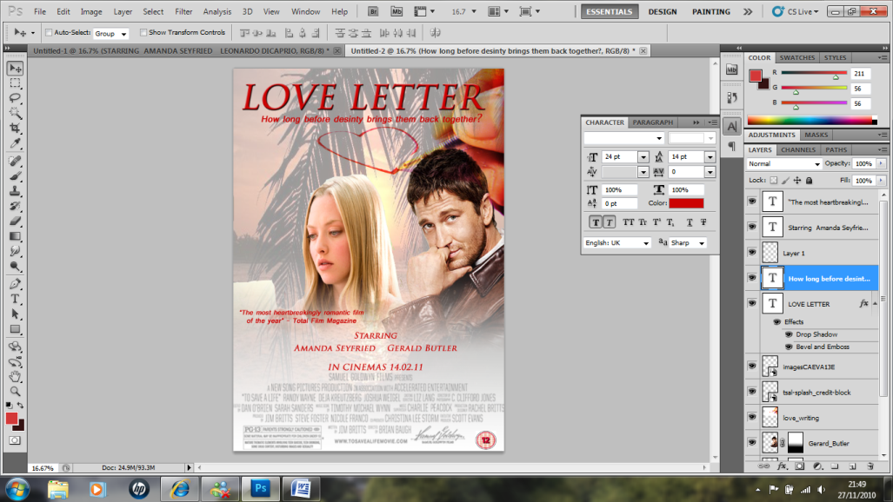

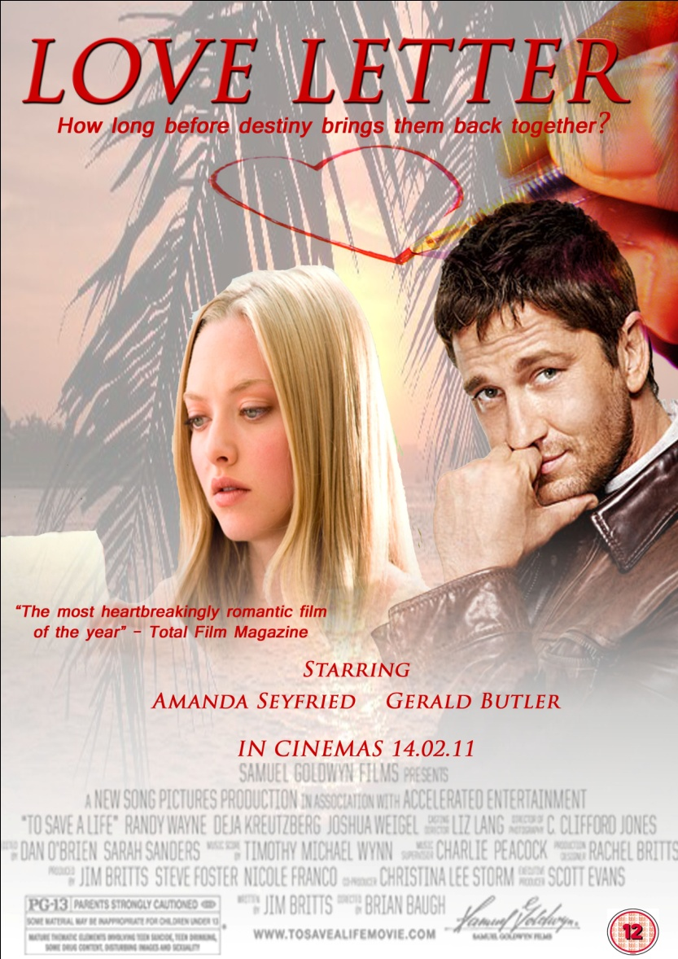
CONGRATULATIONS!! YOU ARE FINISHED!! IT SHOULD NOW LOOK LIKE THIS!!

